Preface

This User Guide explains how to use the system to process received undertakings. It assumes that you are familiar with the basic principles of trade finance relating to guarantees, standbys and dependent undertakings together with web browsers.

# Introduction

This chapter provides an overview of how the system handles Undertakings. The term ‘Undertaking’ in this document is used as generic term to refer to the following different forms of undertaking, either

* Guarantee or
* Standby Letter of Credit (LC) or
* Dependent Undertaking such as *surety*

Undertakings are used where parties are concerned with the obligations between them, rather than specific goods or services.

Undertakings provide security to beneficiaries in the form of a promise by the issuing bank on behalf of the applicant to reimburse the beneficiary for the amount of the standby/guarantee if the applicant defaults. Undertakings are normally subject to the laws and customs of the country of issue. A bank may therefore request a counter undertaking when dealing with a bank in another country. In this case, the issuing bank provides a counter indemnity to the overseas bank to cover the liability incurred by them.

## Undertakings in Trade Innovation

Trade Innovation includes two products to handle Undertakings

* Issued undertaking
* Received undertaking

Issued undertaking - which reflects the transaction from the perspective of the issuing bank. *Issued undertakings* cover the

* issuing of the bank’s own undertaking
* issuing of the bank’s own counter and local undertaking
* processing of received counter undertakings from another bank, where they have been requested to issue their own local undertaking or issue a further counter undertaking/local undertaking against a received counter

Received undertaking – which reflects the transaction from the perspective of the advising bank typically in the beneficiary’s country. *Received undertakings* cover the

* advising the undertaking to the beneficiary
* advising the undertaking to the beneficiary via an *advising bank* or *advise through* bank
* advising of confirmed Standbys where a *Requested confirmation party* can also be specified.

## Renewals, Non-extensions, Increases and Reductions

Undertakings in Trade Innovation can be renewed, reduced or increased automatically, or manually after review, according to schedules defined when the transaction was first entered on your system.

For renewals, these schedules allow you to define when and how often the transaction is to be renewed, and for how much - the original amount of the transaction, or its value at the time of renewal. You can also define whether the customer is to be advised of the renewal, and if so, how soon before the renewal occurs. A non-extension notification can be sent to the customer where the undertaking is not going to be renewed beyond the current expiry date.

For reductions and increases, these schedules define when the transaction is to be increased or reduced, and the amount of the increase or reduction, expressed as a fixed amount or as a percentage of the transaction's value. Again, you can define whether the customer is to be advised of the change of amount, and, if so, how soon before the reduction or increase takes place.

## Payment Terms

The system includes facilities for the handling of **Demand** payments.

There are a number payment options available to the bank allowing them to either ‘pay’, ‘reject’, ‘request to pay or extend’ or ‘extend’ an undertaking.

Where a Demand is:

* Paid – the payment is settled,
* Rejected - it is not paid,
* Requested to be paid or extended – the applicant has the option to either pay or extend the term of the undertaking,
* Extended – the applicant approves the extension to the undertaking and the expiry date is amended to a new requested date.

## Financing and Discounting

If you have the financing module implemented, there are generic features available that allow the bank to enter advances against an undertaking from within payment events. Loans can have interest charged in advance or in arrears, or they can be discounted.

The financing module also allows you to create financing transactions independent of any existing trade finance transaction. The trade finance transaction can then be associated with the financing transaction as it is created.

For a full description of the financing module's functionality see the Financing User Guide – Trade Innovation.

## Assignment of Proceeds

The system allows the assignment of proceeds to additional parties for undertakings. Each transaction can have any number of assignments associated with it, and these can be viewed as part of the master details.

## Licenses

The system includes facilities for the use of licenses with transactions of the type described in this Guide. Your bank can also make returns to the central licensing authority on a regular basis to show the utilisation of the licenses issued to customers.

One or more licenses can be linked to a transaction and a reservation made for the amount of the transaction. When a claim is received, a drawdown can be made against the license. Full validation between the transaction and license is provided to ensure that licenses do not become overdrawn.

If the amount of the transaction is increased or decreased during an amendment event, then additional reservations can be made for an increase or the balance reinstated for a decrease. Any unutilised balance on expiry or cancellation can be (optionally) reinstated on the license.

See the Licenses User Guide – Trade Innovation for details of licenses.

## Participating a Transaction

If you have the participations module implemented, you can participate a transaction using an existing participation deal, or create a new participation deal for use with that transaction.

You can participate a transaction from within the Advise event, or later from within a Maintain Liability event. At either of these stages, you can either select an existing agreed participation deal, or create a new deal.

If the amount of a transaction is changed by an Amend event, or by the transaction being paid, expired, or cancelled, a Drawdown/Revolve Commit Amt event may be created as a subsidiary event to update the commitment amount available on the participation deal. This will occur under the following circumstances:

* If the amount is increased, a drawdown will take place to reduce the amount available on the participation deal.
* If the amount is decreased, including being reduced to zero when the transaction is paid, expired, or cancelled, a revolve will be used to increase the amount available on the participation deal only if the participation deal is defined as revolving.

A Drawdown/Revolve Commit Amt event may be created by the following events:

* Amend
* Cancel
* Expire
* Maintain Liability
* Documents Presented
* Outstanding Presentation
* Renew
* Reduction/Increase

If the participation deal itself is amended in such a way as to alter a participant's share, a Maintain Liability subsidiary event is automatically generated for each transaction affected by the amendment. This updates the transaction and the charges associated with it to take account of changes to the participation deal.

For a full description of using participation deals, see the Participated Deals User Guide – Trade Innovation.

## Credit Risk Management

If your bank has implemented a credit risk management application, your system will perform on-line credit limit checking as necessary as part of the life-cycle of a transaction. Depending on how your system has been configured, account manager approval for a credit line utilisation may be required always, or only when overline conditions are detected.

See the Common Facilities User Guide – Trade Innovation for more information on credit risk management.

## Incorporating Legacy System Transactions into Trade Innovation

Your bank can incorporate received undertakings transactions into the system from a legacy system using customer gateway interface service messages.

Each transaction is received as a customer gateway interface service message, which is processed in the usual way. Each such message, once successfully processed, is used to create an Advice Take-on event and associated master record in the system. The Advice Take-on event can be automatically released, and the master record given a status of 'LIV' or 'EXP', depending on its expiry date. Processing can then be carried out against the master record in the usual way, using the standard received undertaking events.

The transaction's original unique reference is recorded against the master record generated within the system.

To allow legacy transactions to be incorporated into the workflow in this way your bank must set up the following for the Advice Take-on event:

* Postings to allow the calculation of current values of master-level liability and margin amounts at master level within the system
* Charges and default charge schedules
* Tracers and their default schedules
* Note types

The system allows you to enter legacy transactions manually, using the standard Advise event. An additional field is provided (see page 6) to allow you to enter the transaction's unique reference from the legacy system.

## Processing Received Undertakings

The table below list the events covered in this Guide, explaining what each event allows you to do. The table lists the names given to events when the system is delivered. Your bank can change these names once the system is installed. Consequently, the names in your version of the system may be different from the ones listed here.

There are two names for each event:

* The full name, which is displayed when you choose a new event
* The short name, which is displayed in the Work in Progress pane of the Master Summary window

This Guide uses the full name of each event, as delivered with the system.

In addition to the events listed in the table, you can also use the functionality described in the Common Facilities User Guide – Trade Innovation when processing transactions in the system.

| Full Name | Short Name | What it Does |
| --- | --- | --- |
| Adjust | Adjust | Allows you to make changes to any of the information held for an undertaking (see page 61). |
| Advise | Advise | Allows you to create an undertaking and produce a full advice for the beneficiary (see page 6). |
| Advise Reduction/Increase | Adv Rec/Inc | Allows a reduction or increase in the amount of an undertaking to be advised to parties automatically, prior to the reduction or increase (see page 53). |
| Advise Renewal | Adv Renewal | Allow the renewal/non-extension of an undertaking to be advised to parties automatically (see page 48). |
| Advice Take-on |  | An event created automatically to allow received undertakings in a legacy system to be incorporated into the system. |
| Amend | Amend | Allows you to make amendments to the basic details of an undertaking (see page 59). |
| Beneficiary Response to Amend | Amd Rspnse | Allows you to enter details of the beneficiary's response to an amendment (see page 60). |
| Beneficiary Response to Cancel | Can Rspnse | Allows you to enter details of the beneficiary's response to a cancellation (see page 66). |
| Cancel | Cancel | Allows you to cancel an undertaking (see page 65). |
| Documents Presented | Docs Pres | Allows you to record details of documents presented and to make claims against the issuing bank when the beneficiary or another bank presents documents for payment (see page 32). |
| Finance | Finance | Available only if your system has the financing module implemented. Allows you to create an independent financing transaction.  See the Financing User Guide – Trade Innovation. |
| Maintain Liability | Maint Liab | Updates a participated undertaking to take account of changes in the participation deal. See the Participated Deals User Guide – Trade Innovation. |
| Outstanding Presentation | Outst Presn | Allows you to continue processing a previous presentation (see page 39). |
| Receive Acknowledgement | Rec Acknow | Allows you to record the advising bank's acknowledgement of receipt of an undertaking (see page 30). |
| Reduction/Increase | Red/Inc | Allows an undertaking to be reduced or increased automatically (see page 54). |
| Renew | Renew | Allows an undertaking to be renewed automatically (see page 49). |

# Advising a Received Undertaking

This chapter explains how to use the system to initiate a received undertaking on your system using the Advise event.

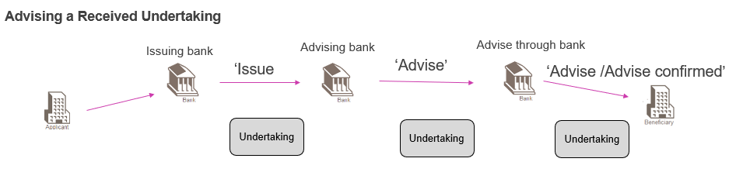

The Advise event can be used to enter details of

* An **Issued undertaking (ISSU)** from the issuing bank
* An **Advice of an Unconfirmed undertaking (ADVI)** from an Advising bank
* An **Advice of a Confirmed undertaking (ACNF)** from an Advising bank

The sending bank may also send details of a ‘Requested confirmation’ party. In this case, your bank can either add their confirmation , if required, or pass on the confirmation request to the next advising bank.

## Advising a Received Undertaking

The Advise event enables you to enter full details of a received undertaking. To initiate an Advise event, in the Masters window, select the Team and Behalf of branch and use the drop-down list in the New Masters pane to select 'Received undertaking', then click **New**. The system creates an Advise event at either a Log step (see page 6) or Input step, depending on how the Workflow orchestration controlling the event is configured. See the *Workflow Tailoring User Guide* – Trade Innovation for details.

If your system has been configured to allow the incorporation of legacy transactions into the system, an Original Reference field is present.

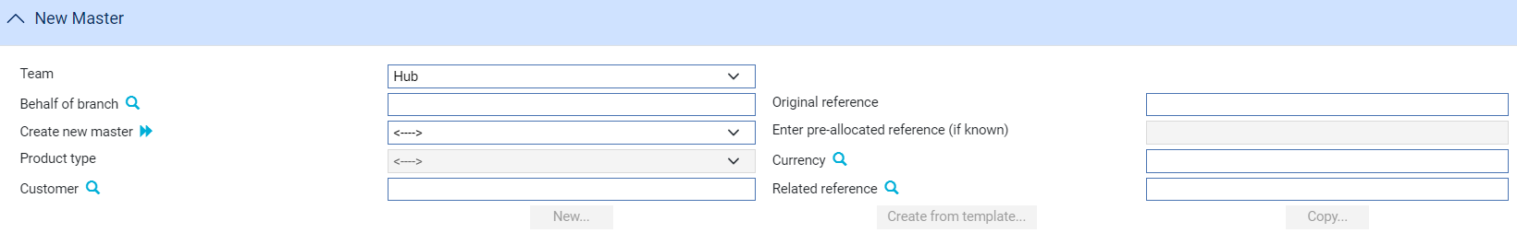

This is for use when entering transactions from the legacy system manually. It allows you to enter the legacy system's unique reference for the transaction. If you enter a value here, it must be unique within the system for received undertakings.

### Logging an Advice

If your system has been configured to have a log step as part of your workflow the system will display a Log window allowing you to enter basic details of the Received Undertaking. See the *SDK - Screen Tailoring User Guide* – Trade Innovation for details.

### Entering Full Details of the Advice

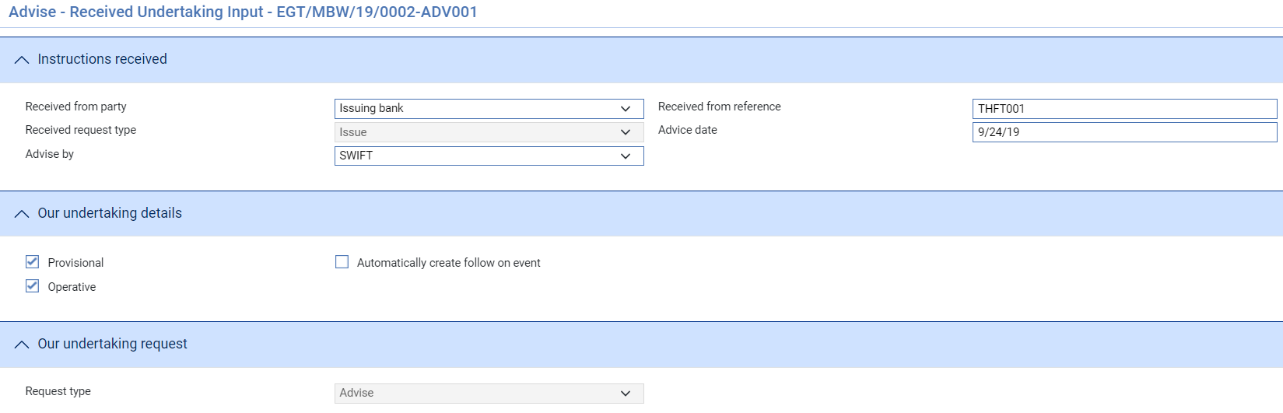

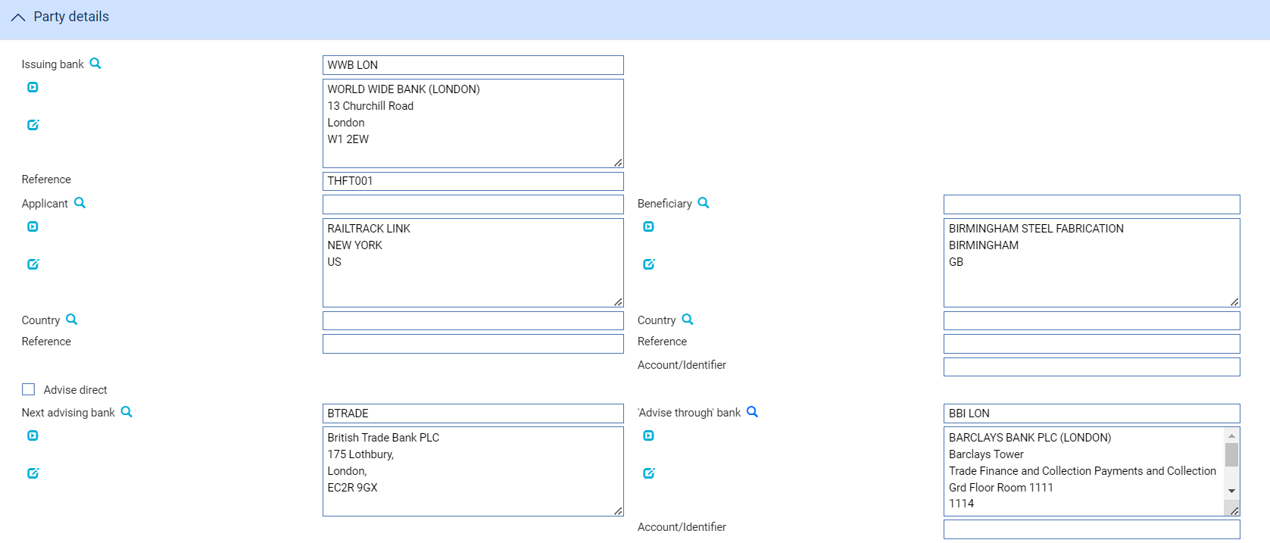

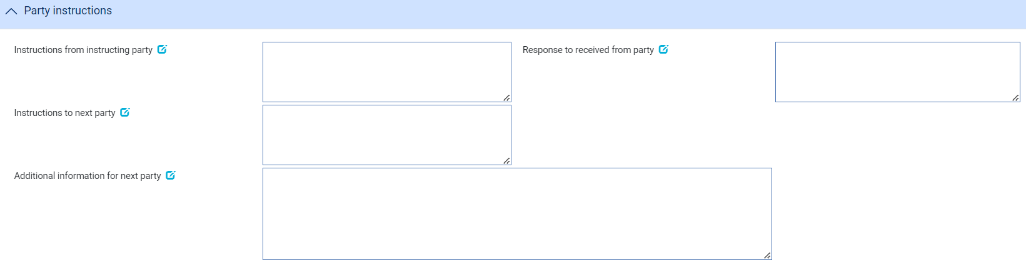

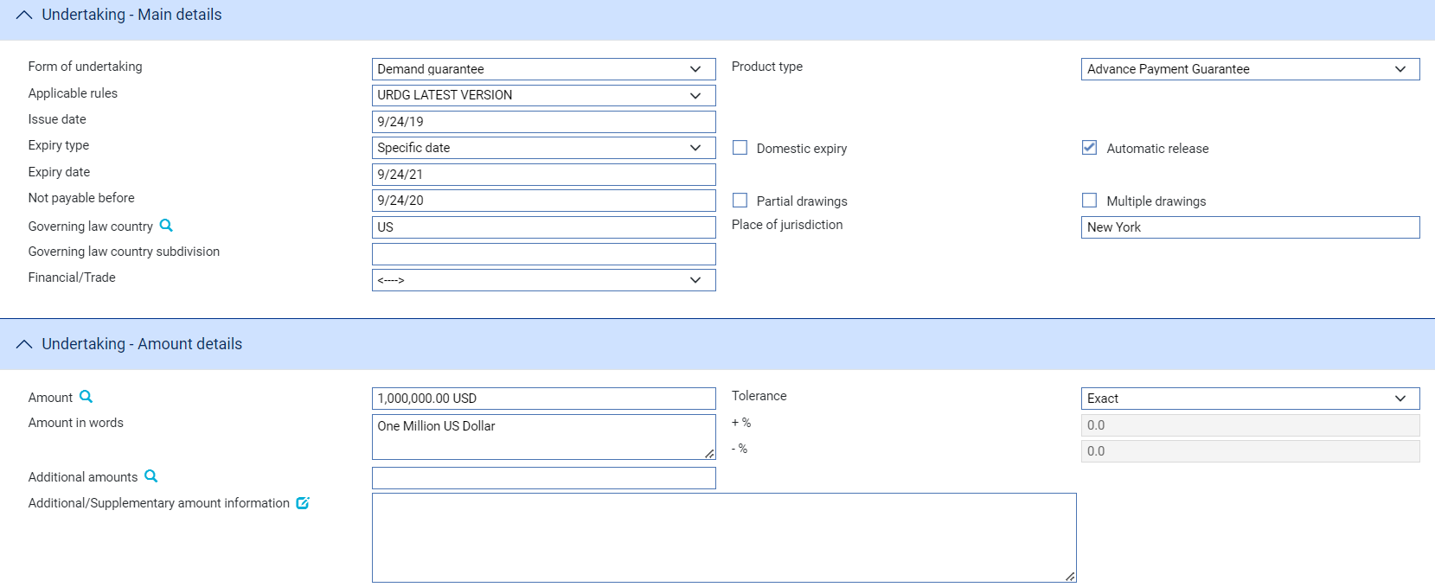

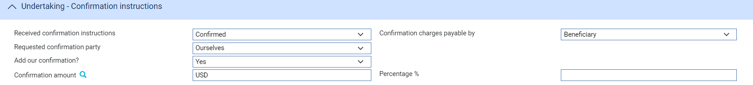





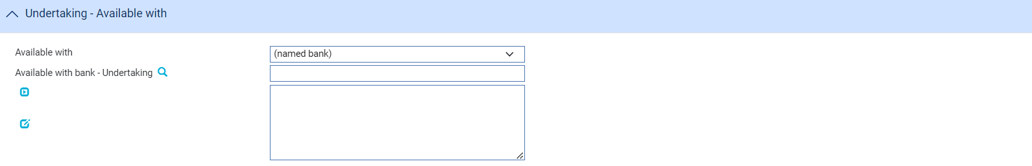

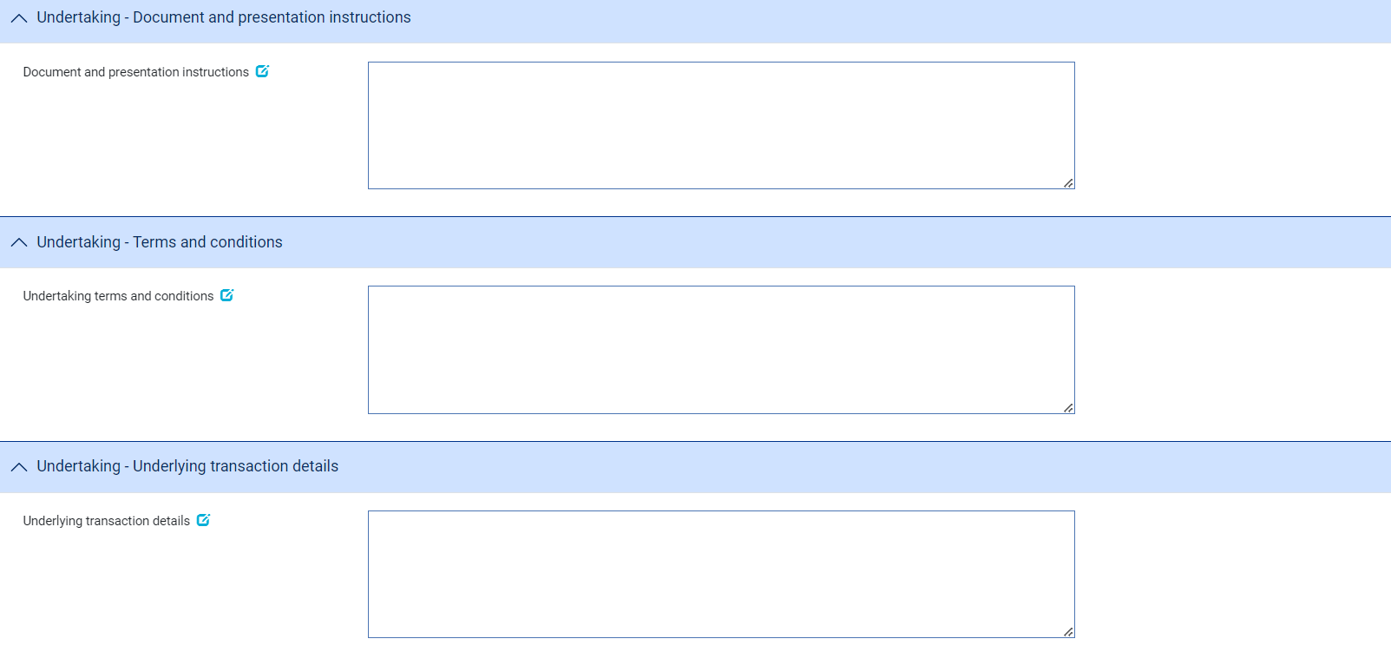

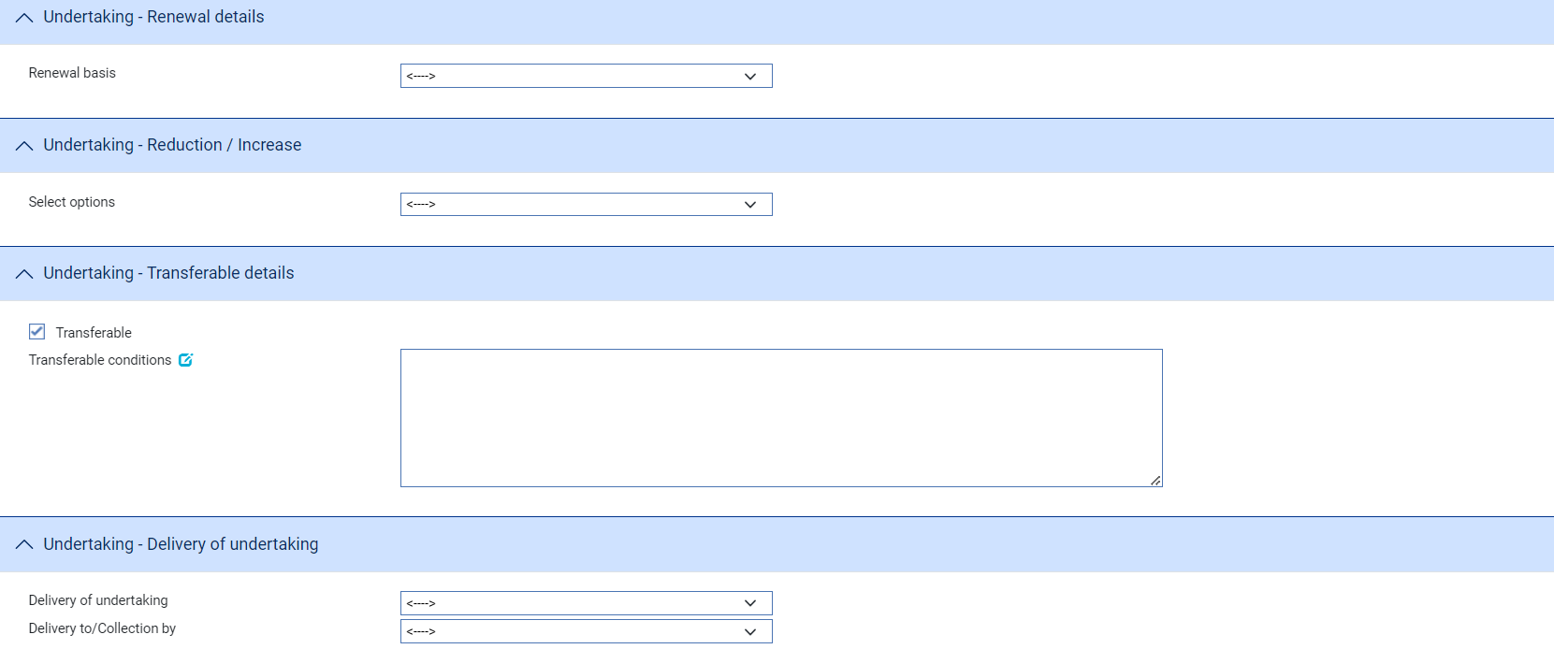

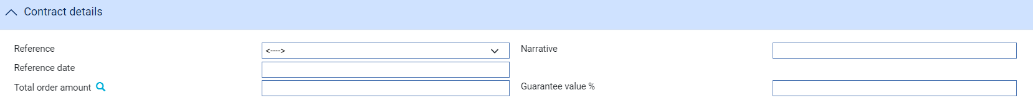

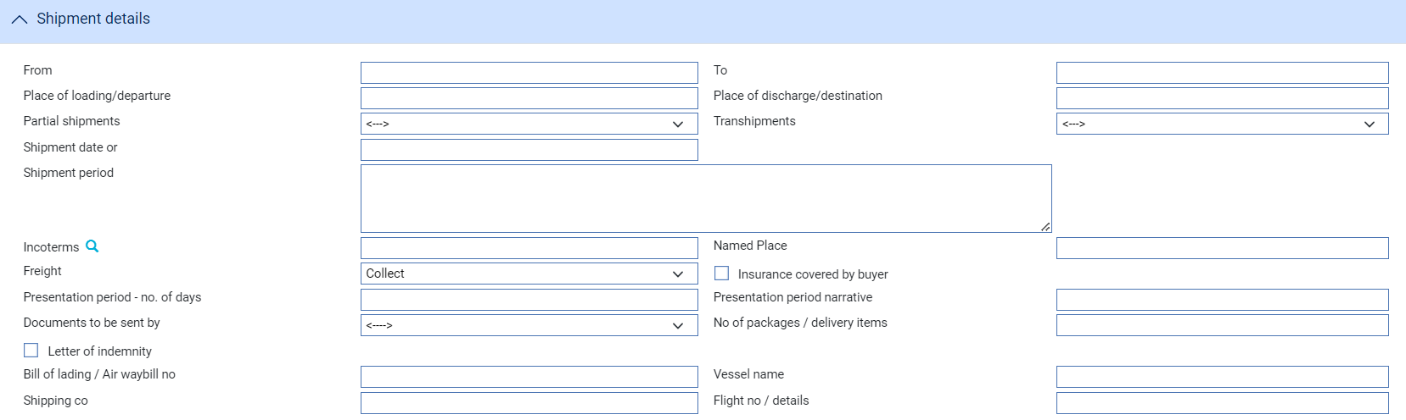

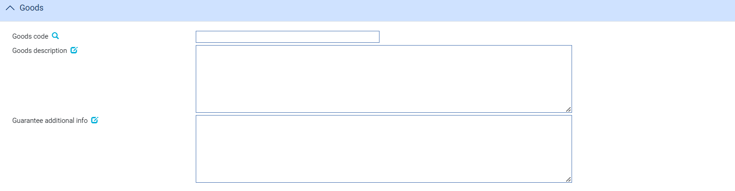

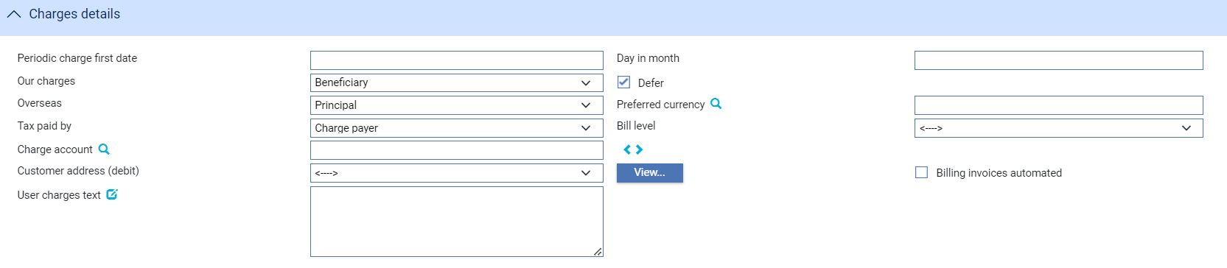

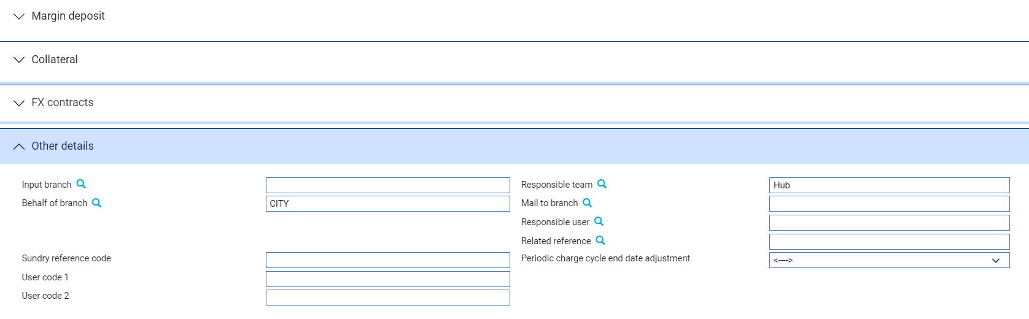

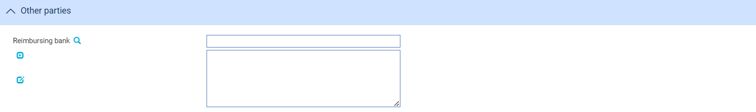

An Input step uses the following panes to enter full details of the advice:

* Instructions received
* Our undertaking details
* Our undertaking request
* Party details
* Party instructions
* Undertaking - Main details
* Undertaking - Amount details
* Undertaking - Confirmation instructions
* Undertaking – Available with details
* Undertaking - Document and presentation instructions
* Undertaking - Terms and conditions
* Undertaking - Underlying transaction details
* Undertaking - Renewal details
* Undertaking - Reduction / Increase
* Undertaking - Transferable details
* Undertaking - Delivery of undertaking
* Contract details
* Shipment details
* Goods
* Charges details
* Margin deposit
* Collateral
* FX contracts
* Other details
* Other parties
* Party list

Instructions on using the Margin Deposit pane, the Collateral pane, the FX Contracts pane and the Party List pane are given in the Common Facilities User Guide – Trade Innovation.

#### The Received Undertaking Details Pane

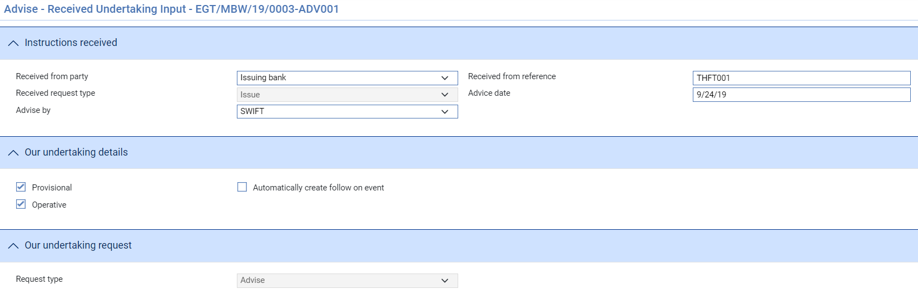

The following table explains what to enter into the fields displayed in the Received Undertaking Details pane.

|  |  |  |
| --- | --- | --- |
|  | Field | What to Enter |
|  | Received from party | The party from whom the Undertaking was received, either   * Issuing bank or * Advising bank |
|  | Received from Reference | The sending bank's reference. This is stored on the master record as the principal party's reference. |
|  | Received Request Type | The type of request received either   * Issue – if received from issuing bank * Advise - if advice of unconfirmed undertaking * Advise confirmed – if advice of confirmed undertaking |
|  | Advice Date | The date the undertaking was created on your system. The system uses today's date as the default. |
|  | Advise By | The method of transmission to be used to advise the undertaking. If you leave this field blank the system will use the method specified in the address details for the recipient of the undertaking. |
|  | Provisional | Whether the event is provisional or final |
|  | Operative | Whether the instrument is operative |
|  | Automatic follow on event | Whether a follow on advise event should be created automatically once this event is completed |
|  | Our request type | Our request type is either   * Advise – if unconfirmed * Advise confirmed – if the undertaking has been confirmed by ourselves or a previous bank |

#### The Party Details Pane

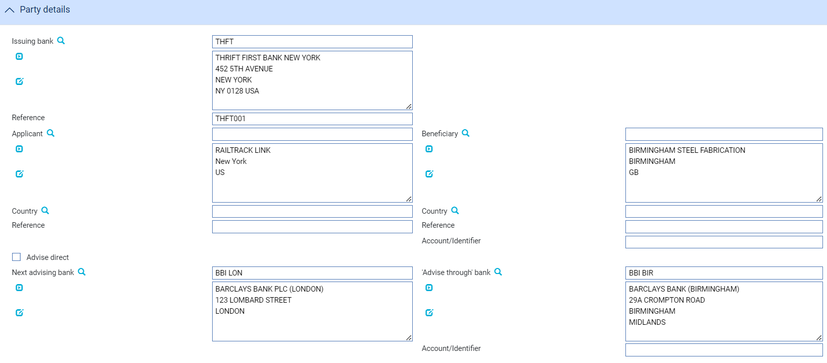

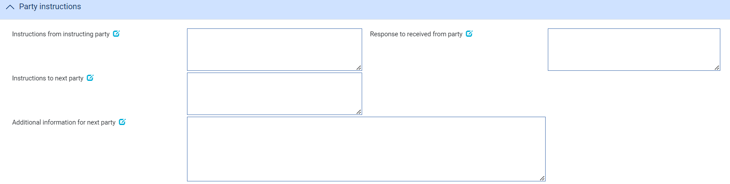

The following table explains what to enter into the fields displayed in this pane:

|  | Field | What to Enter |
| --- | --- | --- |
|  | Issuing bank | The Issuing bank if an ‘Issue’ has been received |
|  | Received From | The received from advising bank where the undertaking has been ‘Advised’ by a party other than the issuing bank |
|  | Applicant | The Applicant details including *Country of residence* and their *Reference* |
|  | Beneficiary | The Beneficiary details including *Country, of residence,* their *Reference* and *Account/identifier* |
|  | Advise Direct | Check this field if the undertaking is being advised directly to the beneficiary. |
|  | Next advising bank | The bank being requested to advise the undertaking. |
|  | Advise through  Bank | The Advise Through bank through which the undertaking is to be advised to the Beneficiary including *Account/identifier* |
|  | Instructions from instructing party | Instructions from instructing party e.g. notes from issuing bank or other previous advising bank |
|  | Response to received from party | Instructions to the received from party e.g. notes for issuing bank or other previous advising bank |
|  | Instructions to the next party | Instructions to the next party e.g. to advise through bank or beneficiary |
|  | Additional information for next party | Additional information for next party e.g. contact number |

#### The Undertaking Details Pane

The following table explains what to enter into the fields in this pane:

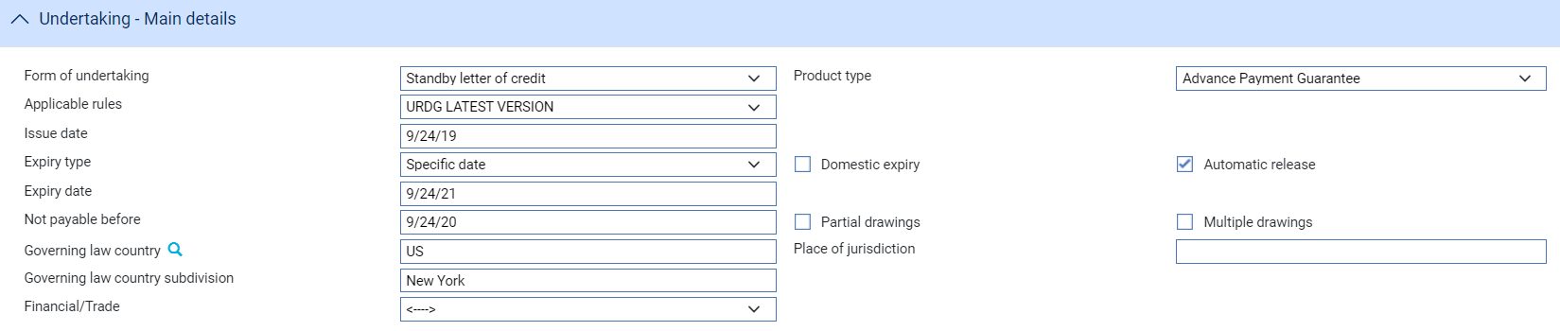

|  | Fields | What to Enter |
| --- | --- | --- |
|  | Form of undertaking | The form of undertaking type can be either   * Demand Guarantee (DGAR) * Standby letter of credit (STBY) * Dependent undertaking (DEPU) |
|  | Product type | The product type associated with the undertaking. |
|  | Applicable rules | Applicable rules to which the undertaking is subject   * ISPR- The version of the International Standby Practices (ISP) that is in effect on the date of issue of the undertaking. * NONE- The undertaking is not subject to any rules. * OTHR -The undertaking is subject to another set of rules, or the undertaking is not subject to the version of the rules that is in effect on the date of issue, these must be specified in Narrative (2nd subfield). * UCPR -The version of the Uniform Customs and Practice for Documentary Credits (UCP) as published by the International Chamber of Commerce (ICC) that is in effect on the date of issue of the undertaking. * URDG -The version of the ICC Uniform Rules For Demand Guarantees (URDG) as published by the International Chamber of Commerce (ICC) that is in effect on the date of issue of the undertaking. |
|  | Applicable rules narrative | Additional text (35 characters) can be added where ‘Other’ has been selected for applicable rules dropdown |
|  | Expiry type | Whether the undertaking has a specified expiry date or is open ended or is dependent on a documentary condition or event   * COND Expiry condition (including option for specified date of expiry). * FIXD Specified date of expiry (either with or without automatic extension). * OPEN No specified date of expiry. |
|  | Expiry date | This field specifies the date when the undertaking will cease to be available. This can only be specified when expiry type is COND or FIXD |
|  | Expiry condition/Event | Narrative can only be entered if Expiry type is ‘Expiry condition’ |
|  | Not payable before | Date from which the undertaking may be paid |
|  | Partial drawings allowed | Whether partial drawings are allowed |
|  | Multiple drawings allowed | Whether multiple drawings are allowed |
|  | Domestic expiry | Whether domestic expiry |
|  | Auto-release undertaking | Whether the undertaking is automatically released on expiry. If set to Yes the Expiry event is automatically generated (and released) after the grace days. If set to No the expiry event is not generated and charges continue to be generated as the undertaking is effectively treated as Open. |
|  | Governing law country | The governing law country that is applicable to the undertaking. |
|  | Governing law country subdivision | The governing law subdivision of the country applicable to the undertaking. |
|  | Governing law text | The governing law that is applicable to the undertaking. |
|  | Financial/Trade | Whether the undertaking is related to underlying trade or financial transaction. If set to Trade and additional section appears allowing the bank to enter further details. |

#### The Amount Details Pane

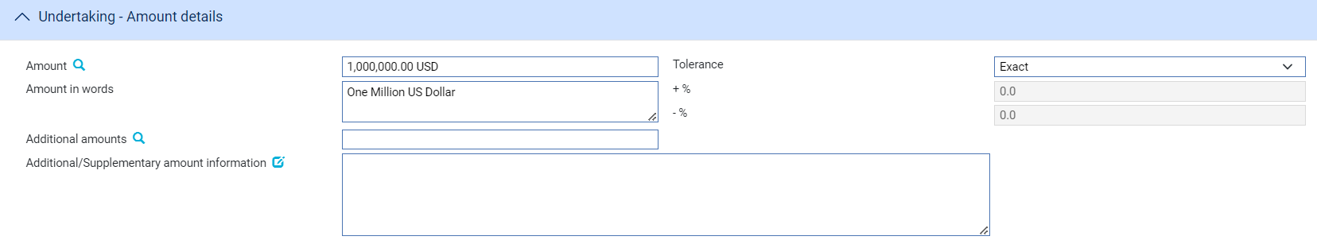

The following table explains what to enter into the fields in the Amount Details pane:

|  | Field | What to Enter | |
| --- | --- | --- | --- |
|  | Amount | The amount and currency of the transaction. The system displays the amount and currency in the language of your system beneath these fields. You can edit this text, if necessary. | |
|  | Tolerance | Specify how the amount is being expressed. Select from one of the following: | |
|  |  | Exact | If the amount is the exact value of the letter of credit. |
|  |  | About | If the amount given in the Amount field is within 10% either way of the expected value of the letter of credit. |
|  |  | Other | If you select this option, use the -% and +% fields to specify as a percentage how much more or less than the final value of the letter of credit the amount entered is allowed to be. |
|  |  | Not Exceeding | If the final value of the letter of credit is expected to be no more than the amount entered, and not less than 95% of the amount entered. |
|  |  | Min/Max | If you select this option the system displays a + Amount and a - Amount field. Use them to specify as an amount how much more or less than the final value of the transaction the amount entered is allowed to be. |
|  | Additional Amounts | Any amounts payable to the beneficiary in addition to the principal amount of the transaction. These might include, for example, local freight charges.  If you enter an amount, it is added to the amount of liability under the transaction. If you use a different currency for the amount, then the amount is converted to the currency of the transaction using the current spot rate. | |
|  | Additional/Supplementary Amount Information | This field can be used to add details about additional amounts related to the undertaking e.g. interest, tolerances. This field is a ‘clause’ text field allowing additional amounts and tolerance details entered to be mapped to this text field | |

#### The Confirmation Details Pane



In the Received confirmation instructions field select one of the following values:

|  |  |
| --- | --- |
| Field | What it Shows |
| Confirmed | If you have been instructed by the issuing bank to add your confirmation. |
| Unconfirmed | If you have been instructed not to add your confirmation. |
| May Add | If you have been instructed that you may add your confirmation at the beneficiary's request. |

If you select 'Confirmed' or 'May Add' additional fields are displayed.



The Requested Confirmation Party can then be set to either Ourselves, Received from Advising bank, Next advising bank, Advise through bank or Other.

If set to ‘Ourselves’ then you can enter the amount of the credit that is confirmed. You may enter an amount or a percentage; this is usually 100%.

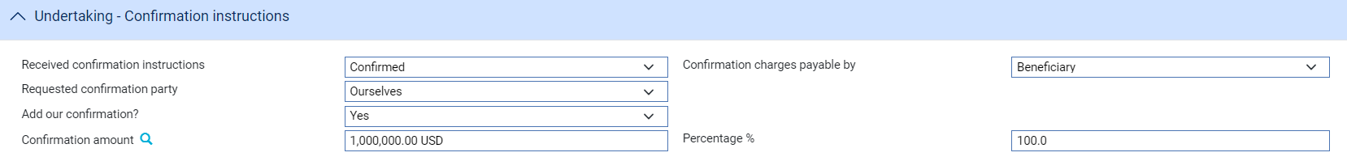

If set to another ‘Requested confirmation party’ then the Confirmation request can be passed to that party via SWIFT or other method:



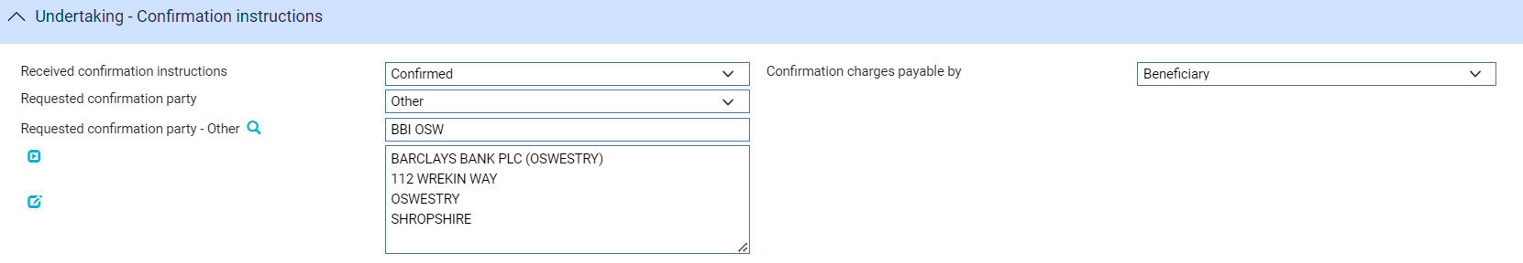

If you have received no confirmation instructions (and the Confirmation Requested field is set as 'Unconfirmed') the Silent Confirmation field allows you as advising bank to confirm the transaction at the request of the beneficiary. Again, additional fields are present that allow you to enter the amount of the credit that is confirmed.



If a transaction receives silent confirmation in this way, it is otherwise still treated as unconfirmed.

#### The Available With Details Pane

The Available with bank details can be entered for a Standby LC or Dependent undertaking.

The drop-down has the following values available allowing you to enter the details or select a named party

* (named bank)
* Any bank
* Any bank in city
* Any bank in country
* Next Advising bank
* Advise through bank
* Issuing Bank
* Ourselves

If (named bank) is selected, you can enter full details of a specific bank.

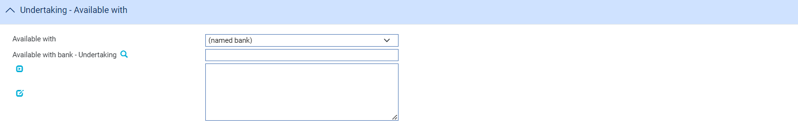

If Any bank is selected, the following details are displayed.



If Any bank in country is selected, the following details are displayed allowing a country to be selected.

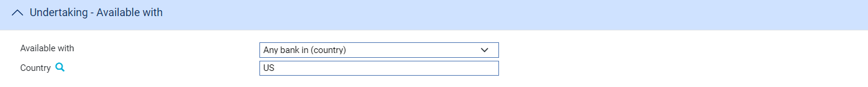

If Any bank in city is selected, the following details are displayed allowing a city name to be entered.



A named party is simply selected from the list as follows:



#### The Instructions Pane

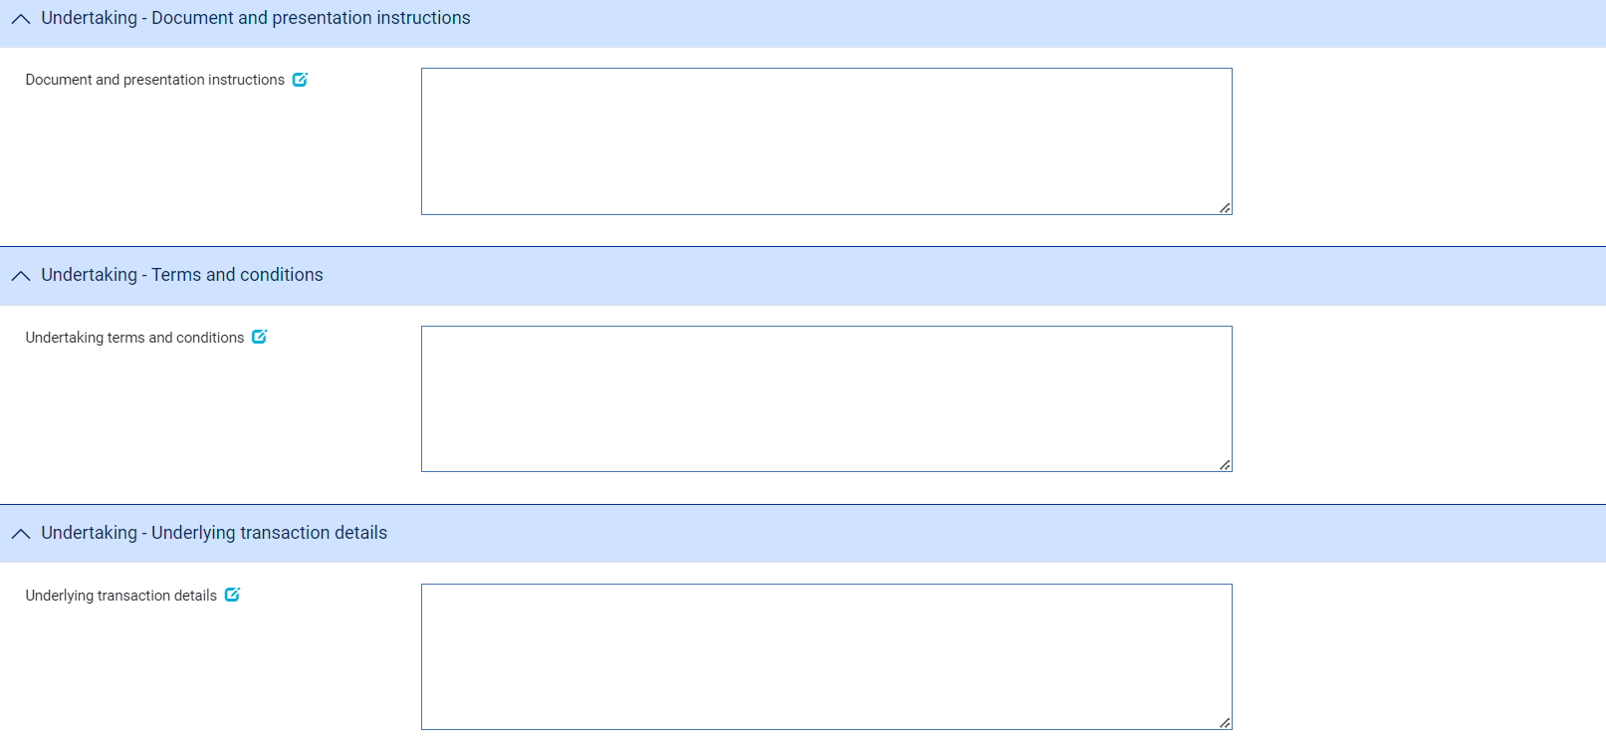

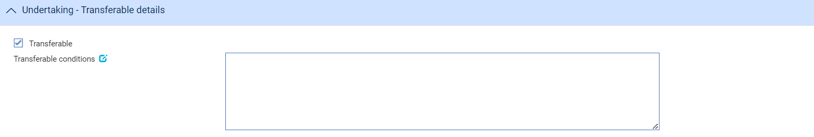

The following table explains what to enter into the fields in the Instructions pane:

|  |  |  |
| --- | --- | --- |
|  | Field | What to Enter |
|  | Document and presentation instructions | A narrative description of documents required and presentation instructions |
|  | Undertaking terms and conditions | The terms and conditions covering the standby, guarantee or dependent undertaking |
|  | Undertaking transaction details | Information relating to the underlying transaction related to the undertaking |
|  | Transferable | Whether the undertaking can be transferred to another party. |
|  | Transferable conditions | Conditions under which transfer is allowed |

#### The Undertaking Renewals

##### The First Renewal and Rolling Renewal Panes

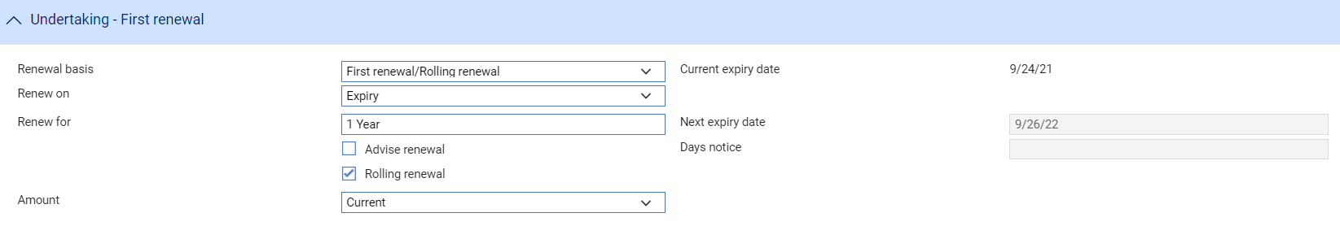

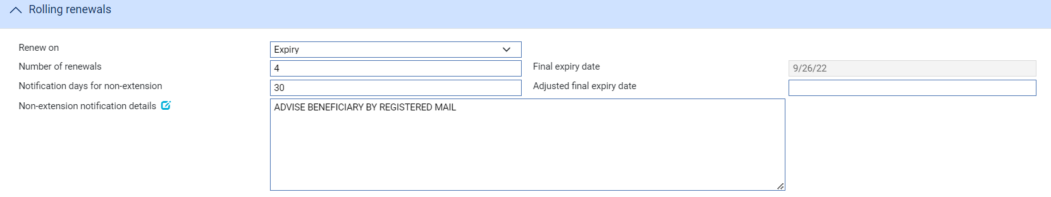

The fields in the First Renewal pane allow you to specify schedules for renewal. The fields in the Rolling Renewal pane are used to enter additional information for rolling renewals.

1. This information is not automatically mapped to outgoing SWIFT messages. Clauses should be used to map details of the first and rolling renewals into the relevant fields for SWIFT.

The following table explains what to enter into the fields in these panes:

| Field | What to Enter |
| --- | --- |
| Renew On | Select whether the undertaking is to be renewed on expiry on a calendar date. Then click **Refresh**. |
| Calendar Date | If you select 'Calendar' in the Renew On field, enter the date on which the undertaking is to be renewed. |
| Renew For | The renewal period. |
| Next Expiry Date | The system calculates and displays the next expiry date. This date cannot be overwritten. |
| Advise Renewal | If the parties are to be advised of the renewal, check this box, then enter a figure into the Days Notice field to indicate how soon before the renewal an advice notice is to be produced for them. |
| Rolling Renewal | Check this box if the renewal is a rolling renewal, meaning that it will be renewed more than once. The following additional fields appear: |
| Amount | Select 'Original' if the undertaking is to be renewed using the original amount; and 'Current' if it is to be renewed at the available amount at the time of the renewal. If you select 'Original', then any margin deposit amount is also increased to its original value. |
| Renew On | Select 'Expiry' if renewal is to occur automatically on expiry of the undertaking. Select 'Every' if renewal is to occur periodically, then click **Refresh**. In the fields that appear specify the period. |
| Frequency | The frequency with which the renewal is to take place. |
| Day in Month | If the frequency is monthly or longer, specify the day of the month on which the renewal should take place. |
| Number of Renewals | Enter a figure to indicate how many times the undertaking is to be renewed. This information is mandatory and the default is 1. |
| Adjusted final expiry date | Adjusted final expiry. |
| Notification days for non-extension | The number of days notice the customer is to be given of cancellation of the rolling renewal. |
| Non-extension notification details | Information related to the non-extension to the automatic expiry date extension,  such as notification method, and notification recipient details. |

##### The Regular Renewal Panes

Calendar

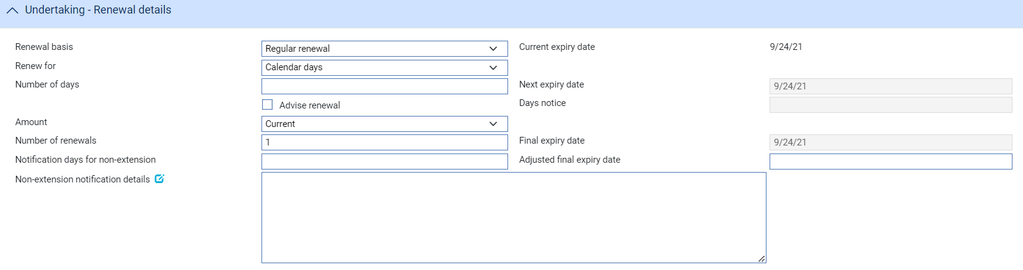

One year same day



Other

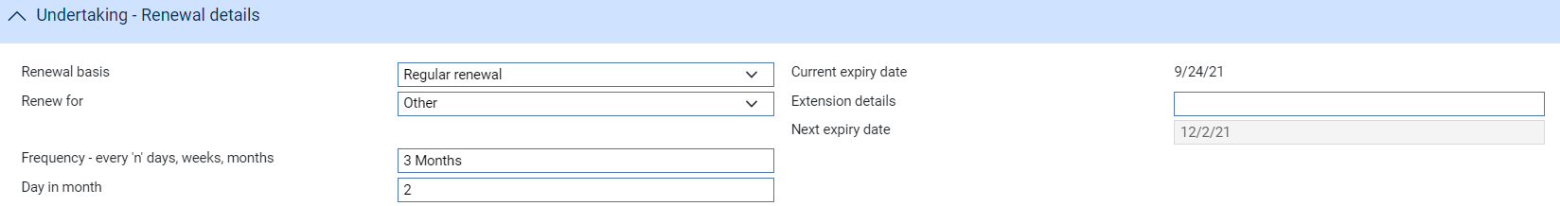

The fields in the Regular renewal pane allow you to specify the schedule for renewal. The following table explains what to enter into the fields in this pane:

| Field | What to Enter |
| --- | --- |
| Renew for | Select either   * Calendar days – enter the number of days for the renewal * One year same day – same day one year later * Other – enter the extension details description together with the renewal details frequency e.g. every ‘n’ days, weeks, months and day in month if the frequency is monthly or longer |
| Next Expiry Date | The system calculates and displays the next expiry date. This date cannot be overwritten. |
| Advise Renewal | If the parties are to be advised of the renewal, check this box, then enter a figure into the Days Notice field to indicate how soon before the renewal an advice notice is to be produced for them. |
| Amount | Select 'Original' if the undertaking is to be renewed using the original amount; and 'Current' if it is to be renewed at the available amount at the time of the renewal. If you select 'Original', then any margin deposit amount is also increased to its original value. |
| Number of Renewals | Enter a figure to indicate how many times the undertaking is to be renewed. This information is mandatory and the default is 1.The system calculates the final expiry date. |
| Adjusted final expiry date | Adjusted final expiry. |
| Notification days for non-extension | The number of days notice the customer is to be given of cancellation of the rolling renewal. |
| Non-extension notification details | Information related to the non-extension to the automatic expiry date extension,  such as notification method, and notification recipient details. |

#### The Reduction/Increase Pane



The fields in the Reduction/Increase pane allow you to specify schedules for reductions and increases. Reductions/increases can be regular or irregular, and the fields used to define them differ accordingly. If the applicant is to be advised of any reductions or increases, check the Advise Reduction/Increase box and enter the number of days notice to be given in the Days Notice field.

For regular reductions/increases, select 'Regular' in the Select Options field.

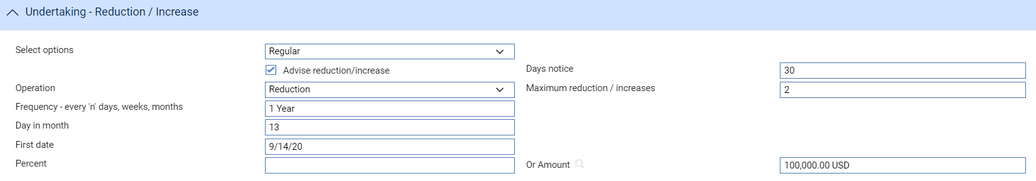

The Regular Reduction/Increase pane is displayed. The following table explains what to enter into the fields in this pane:

| Field | What to Enter |
| --- | --- |
| Operation | Select whether the amount is to be reduced or increased. |
| Maximum Reduction/Increases | If you selected Increase in the previous field, specify here the maximum number of increases that are to be allowed. |
| Frequency | The frequency at which the reduction/increase is to take place. |
| Day in Month | If the frequency is monthly or longer, specify the day of the month on which the reduction or increase will take place. |
| First Date | The system calculates the date of the first reduction/increase and displays it here.  If you left the Frequency field blank, for example if there is to be a single reduction/increase, then you can enter the date on which the reduction/increase is to take place here. |
| Percent/Or Amount | Specify the amount of each reduction/increase. You can specify this as a percentage of the original amount of the transaction, or as an amount. |

For irregular reductions/increases, select 'Irregular' in the Select Options field.

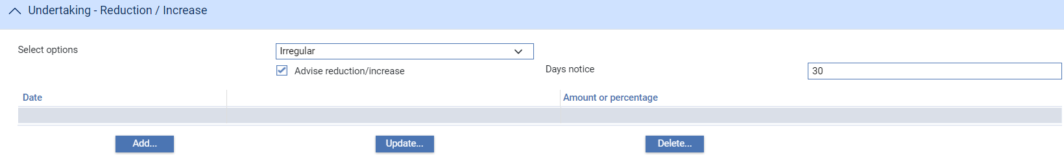

Click the **Add** button in the Irregular Reduction/Increase pane.

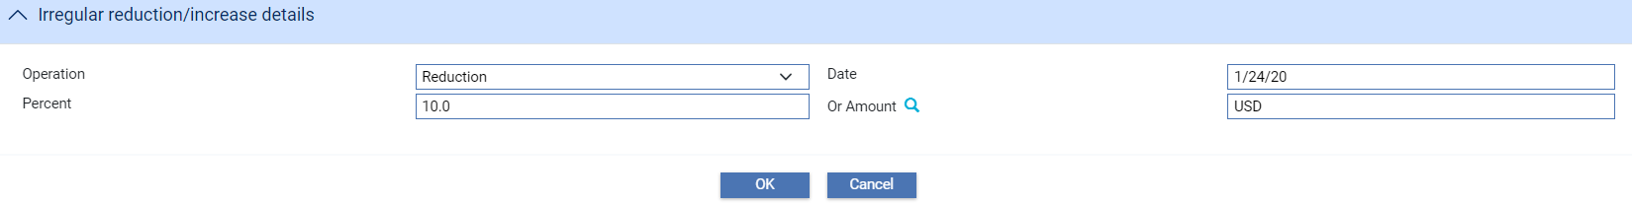

Use the fields in this window to specify in turn each of the reductions/increases that are to take place, and their date and amount.

Use the Operation field to select whether the undertaking is to be reduced or increased. Use the Date field to enter the date the first reduction/increase will take place. Use either the Percent field or the Or Amount field to specify the amount by which the undertaking is to be reduced/increased.

When you close this window, the reductions/increases specified are listed in the Irregular Reduction/Increase pane, where you can amend and delete them in the usual way.

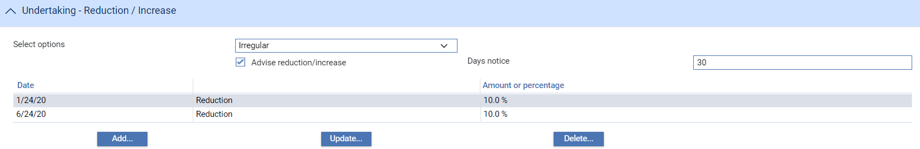

#### The Transferable Details Pane

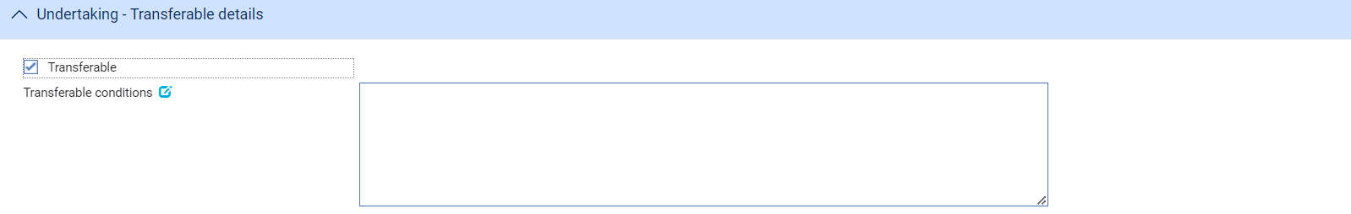

The following table explains what to enter into the fields in the Transferable details pane:

|  |  |  |
| --- | --- | --- |
|  | Field | What to Enter |
|  | Transferable | Whether the undertaking can be transferred to another party |
|  | Transferable conditions | Conditions under which transfer is allowed |

#### The Delivery of Undertaking and Delivery To/Collection by pane

Beneficiary

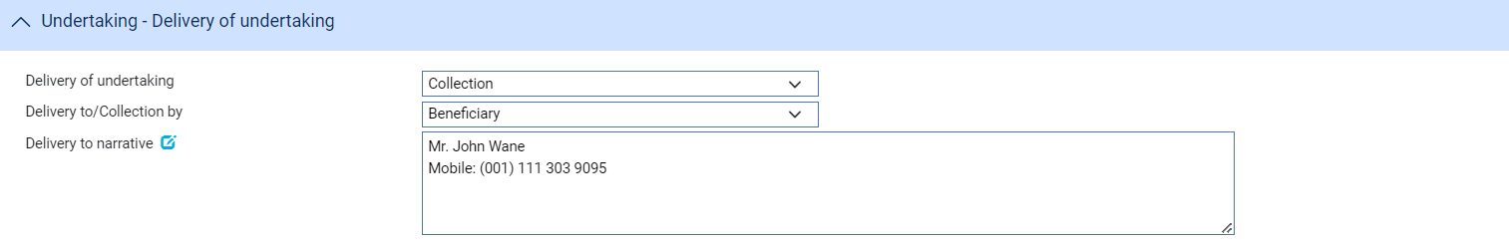

Other addressee

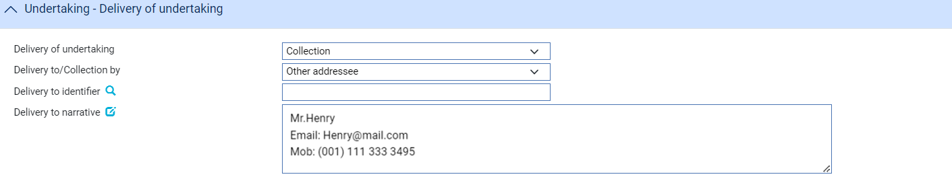

The following table explains what to enter into the fields in the Contract Details pane:

|  |  |
| --- | --- |
| Field | What to Enter |
| Delivery of undertaking | Enter the method to be used to deliver the undertaking. Select either   * Collection * Courier * Mail * Message - hand deliver * Other method * Registered Mail or Air Mail |
| Additional information | Enter any additional information when either Courier or Other method is selected |
| Delivery to/Collection by | Select either   * Beneficiary * Other addressee – this allows details of the party to whom the undertaking is to be delivered/collected by to be entered. |
| Delivery to identifier | Available where selection to the field ‘Delivery to/Collection by’ is “Other addressee”. Allows the user to search the party and when selected shall populate into the ‘Delivery to narrative’ field. |
| Delivery to narrative | Allows the user to enter the delivery instructions that could include the Party name, address and other related instructions. |

#### The Contract Details Pane



The following table explains what to enter into the fields in the Contract Details pane:

| Field | What to Enter |
| --- | --- |
| Reference | This field defines the contract reference type associated with the undertaking.  The codes available are:   * TEND = TENDER * ORDR = ORDER * CONT = CONTRACT * OFFR = OFFER * DELV = DELIVERY * PINV = PROFORMA INVOICE * PROJ = PROJECT |
| Narrative | The narrative is used to describe the contract reference details. |
| Reference date | The contract reference date is used to specify the date of the reference, and optionally a secondary date (tender closing date). |
| Tender closing date (only shown when Reference=TENDER) | The tender closing date may only be used when the contract reference consists of TEND (TENDER) to specify the tender closing date. |
| Total order/contract amount | The total order amount specifies the currency and total amount of the order/contract. |
| Guarantee value % | The guarantee value as a percentage in relation to the total order or contract value. |

#### The Shipment Details Pane

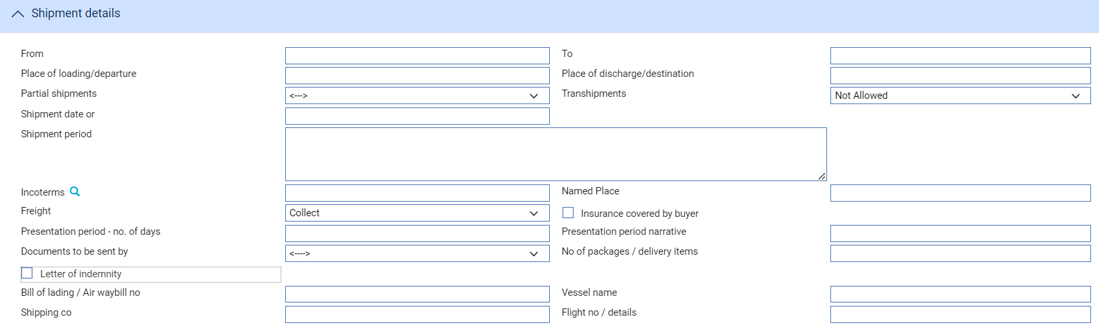

The Shipment Details pane is displayed only for trade-related undertakings. The following table explains what to enter into the fields in this pane:

|  | Field | What to Enter |
| --- | --- | --- |
|  | From | The port the goods are to be shipped from. |
|  | To | The port the goods are to be shipped to. |
|  | Place of Loading/Departure | The place of loading |
|  | Place of discharge/destination | Place of discharge |
|  | Partial shipments  /Transhipments | Select either   * Blank – no specified * Allowed - If partial shipments/transhipments are permitted for this letter of credit. * Not allowed - If partial shipments/transhipments are not permitted for this letter of credit * Conditional - If selected then the user should specify conditions in the required narrative field. |
|  | Shipment Date | The latest date the goods are to be loaded or despatched. |
|  | Shipment Period | A narrative text specifying the period of time during which goods are to be loaded or despatched. |
|  | Incoterm | Selected incoterm |
|  | Incoterm named place | Incoterm named place |
|  | Freight | When you select a value in the Incoterms field, the system automatically selects the appropriate value in this field using information set up for the selected incoterms to indicate whether freight is to be pre-paid or paid on collection. You can override this value. |
|  | Insurance covered by | When you select a value in the Incoterms field, the system automatically selects the appropriate value in this field using information set up for the selected incoterms to indicate whether the buyer is to provide insurance cover or not. The field is checked if insurance cover is to be provided by the buyer. You can override the value displayed here |
|  | Presentation Period | The latest date allowed for presentation of documents by the beneficiary. |
|  | Documents to be Sent By | The method to be used to send documents. |
|  | No of packages/delivery items | Specify how many mailings are to be made. |
|  | Letter of Indemnity | Check this box if a letter of indemnity is required. |
|  | Bill of Lading/ Air Waybill No. | The reference number of the bill of lading or air waybill. |
|  | Vessel Name | The name of the vessel, if known. |
|  | Shipping Co. | The name of the shipping company transporting the goods. |
|  | Flight No/Details | The flight number. |

#### The Goods Pane

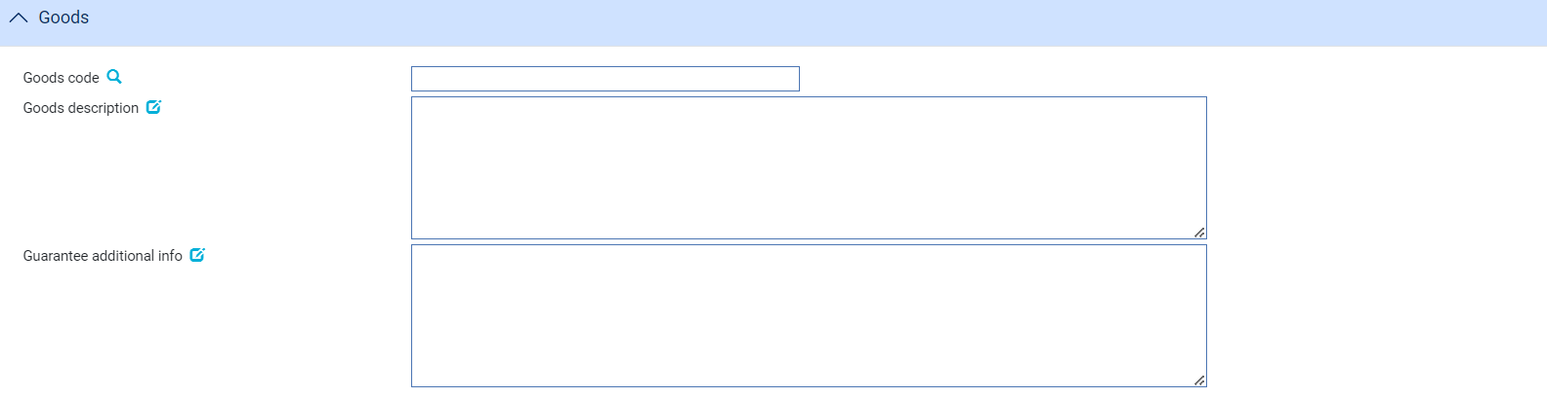

The Goods pane is displayed only for trade-related undertakings. The following table explains what to enter into the fields in this pane:

|  |  |  |
| --- | --- | --- |
|  | Field | What to Enter |
|  | Goods Code | Select a goods code. This field is for analysis purposes. |
|  | Goods Description | A narrative description of the goods being shipped. |
|  | Guarantee Additional Info | For guarantees, any additional information relating to the goods and documents to be sent. |

#### The Charges Details Pane

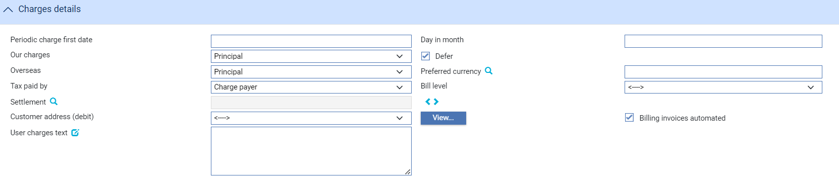

The following table explains what to enter into the fields in this pane:

| Field | What to Enter |
| --- | --- |
| Periodic Charge First Date | The date periodic charges are first to be taken. If charges are taken in advance, enter the date on which charges are next to be taken. |
| Day in Month | The date on which charges are to be debited each month. |
| Our Charges | Select whether the charges are to be paid by the applicant or the beneficiary, then click Refresh. |
| Defer | Indicate whether your own charges are to be collected now or deferred until payment. Check this box if the charges are to be deferred, otherwise leave it blank. |
| Overseas | Specify which party - the beneficiary (the default) or the applicant - will pay overseas charges. |
| Preferred Currency | Specify the currency in which the applicant's charges will be collected. Typically, you would set this to your local currency. If you leave this field blank, the system uses the currency of the transaction. |
| Tax Paid By | Specify which party - the party liable for charges (the default) or your customer - will pay any tax due on charges on the undertaking. |
| Bill Level | Select whether charges for this undertaking should be billed at customer level, transaction level or product level. |
| Charge Account | The account to be used to fund the charges. |
| Customer address (debit) | The charge payer customer’s address defaults to their prime address. The customer’s alternative address can be selected using the list field.   1. This list excludes the customer’s prime and SWIFT address types. Use the adjacent View button to display the chosen address in full. |
| Billing invoices automated | This check box can be used to indicate whether the invoices for charges generated by the transaction (e.g. Billing settlement event) are automatically generated or not. |
| User Charges Text | Any additional information concerning the charges. |

#### The Other Details Pane

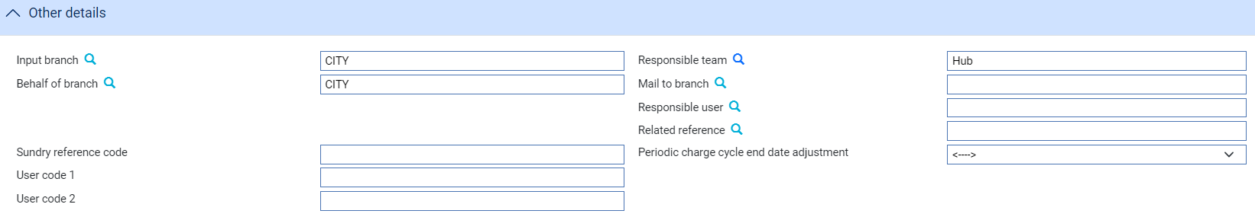

The following table explains what to enter into the fields in the Other Details pane. This pane may also include input fields defined by your bank:

|  | Field | What to Enter |
| --- | --- | --- |
|  | Input Branch | The input branch for the transaction. The input branch is set from either:   * the accounting branch from the user’s team, or * the transaction branch for user if the user has a default transaction branch or is locked to a specific branch, or * a branch associated with the user where the user can enter transactions for several branches for a team |
|  | Behalf Of Branch | The behalf of branch for the transaction as entered by the user or set from the incoming SWIFT or gateway message. The behalf of branch determines the parameter sets that are to be used to generate charges, documents, postings, etc. during transaction processing. The branch can be changed to any other branch within the same main banking entity that shares the same parameter sets. |
|  | Sundry Ref Code /User Code 1/ User Code 2 | You may use these fields to enter values for analysis purposes. Your bank will have devised its own system for using these fields. |
|  | Responsible Team | The team that has overall responsibility for the master e.g. as the contact to resolve any queries or issues regarding the master and associated events. The system defaults the responsible team when creating the transaction as follows:   * Manual – set from team creating the transaction * Gateway – set from the team specified on the incoming message (if present and valid) otherwise to the team to which the transaction is assigned through workflow allocation based on the behalf of branch * SWIFT – set to the team to which the transaction is assigned through workflow allocation based on the behalf of branch   It can be changed, if required, to either the team associated with the primary customer, default team for the product or the user’s current team. |
|  | Mail To Branch | The mail to branch can be set to any branch within the main banking entity of the behalf of branch. |
|  | Responsible User | A user that has responsibility for the master e.g. as the contact to resolve any queries or issues regarding the master and associated events. This can be any user assigned to the responsible team. |
|  | Related Reference | You can specify any other transaction to which this undertaking is related. This may already have been done when the master record was created. You can use the browser to select from possible references to include. |
|  | Periodic charge cycle end date adjustment | Select what happens when a periodic charge cycle end date falls on a non-business/working day. See the *System Tailoring User Guide – Trade Innovation* for more information. |

#### The Other Parties Pane

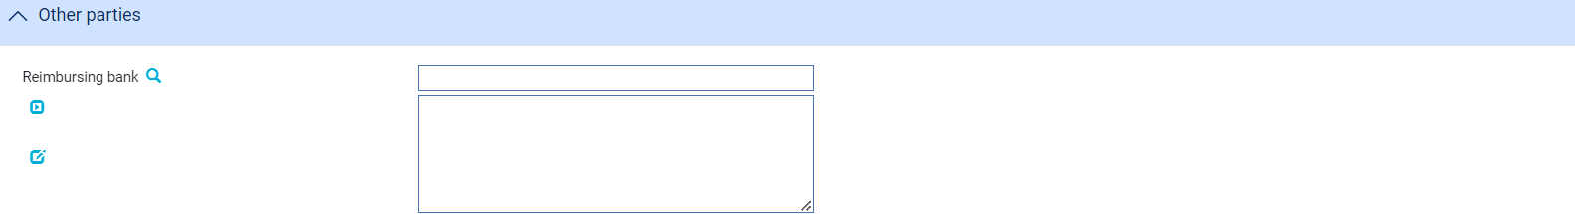

The following table explains what to enter into the fields in the Other Parties pane for a received undertaking:

|  |  |
| --- | --- |
| Field | What to Enter |
| Reimbursing Bank | The bank from whom reimbursement is to be requested. |

#### The Miscellaneous details

Where the *EnableUndertakings* system option is set on, the system displays the enhanced undertaking screens. When an existing transaction has some data that is no longer directly relevant to undertakings, this data is retained but shown in a separate window.

The following details are displayed in Miscellaneous data window. The menu option is only displayed if any of these fields are non-blank, but only fields that have data are shown in the window.

* Customer counter received
* Customer counter expiry date
* Expiry place
* Available By details
* Drafts drawn details
* Additional conditions
* Guarantee additional info
* Goods description
* Bank defined fields (controlled by system option and TF dictionary values)
* ReceiverOfUndertakings
* UT1xxx
* UT2xxx
* Special payment instructions for beneficiary
* Special payment instructions for receiving bank
* Instructions to paying bank

The window is accessed from the left hand menu as follows

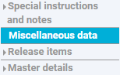

The following screen shows an example of the Miscellaneous details screen. 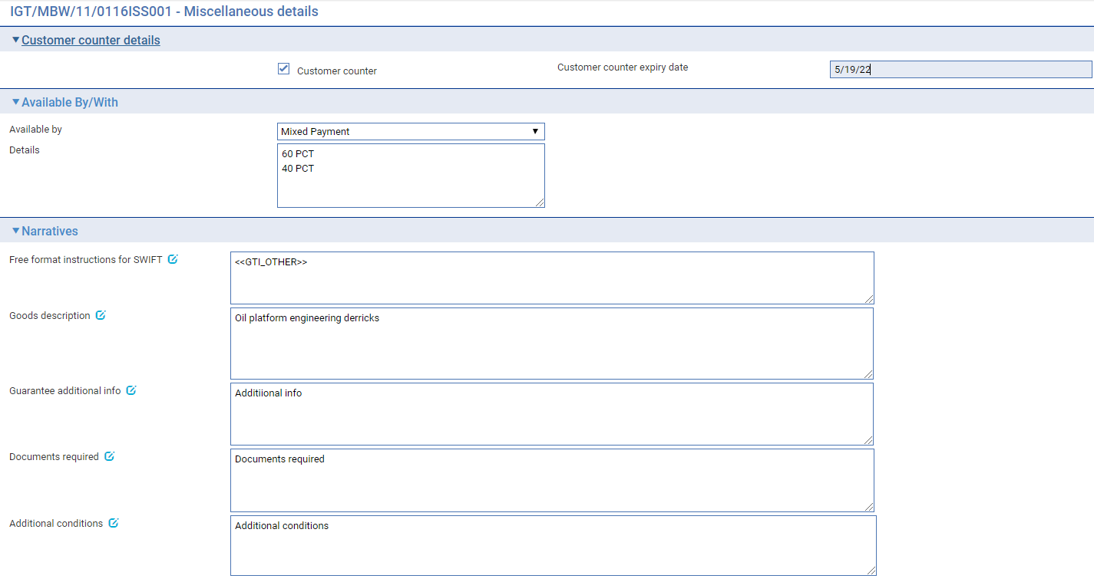

### The Received Undertaking Master Summary Window

Once you create a received undertaking, the system displays the basic details of the undertaking using the Master Summary window.

The screen is distributed into 4 areas

* Applicant details
* Beneficiary details
* Issuing bank/Received from bank details
* Our undertaking request details

The **More...** button allows the user to see the current status of the master

### Details

* The following details are shown for a **Received - Issue (ISSU) undertaking.**

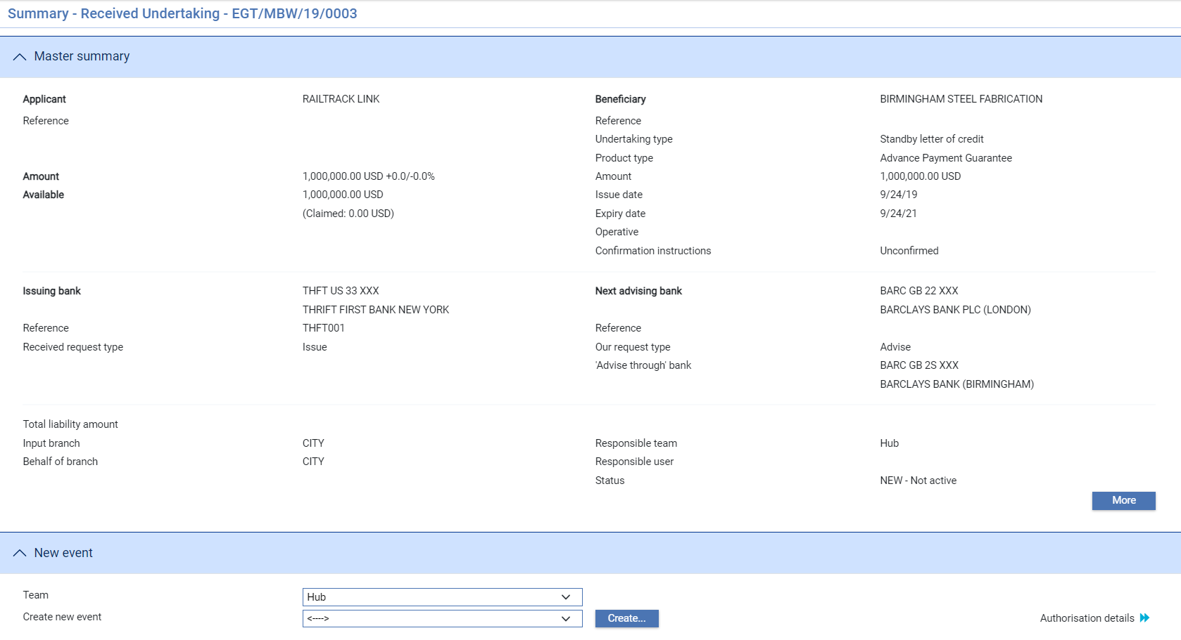

|  |  |
| --- | --- |
| **Applicant**   * Applicant * Applicant reference * Guarantee amount * Available amount and outstanding claim amounts * Additional amounts | **Beneficiary**   * Beneficiary * Beneficiary reference * Undertaking type * Product type * Amount * Issue date * Expiry date * Operative * Confirmation details |
| **Issuing bank details**   * Issuing bank * Received request type - *Issue* | **Our undertaking request details**   * Next Advising bank * Our request type *– either Advise or Advise confirmed* * Advise through bank |

* The following details are shown for a **Received - Advise (ADVI/ACNF)** undertaking

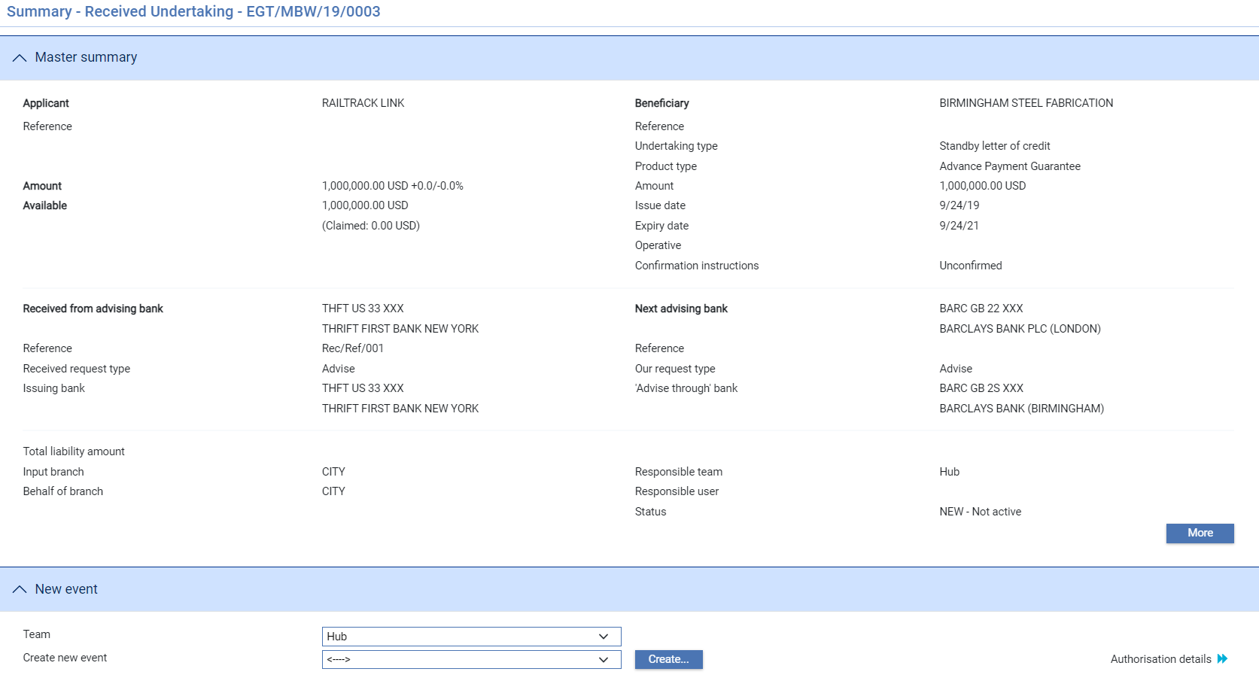

|  |  |
| --- | --- |
| **Applicant**   * Applicant * Applicant reference * Guarantee amount * Available amount and outstanding claim amounts * Additional amounts | **Beneficiary**   * Beneficiary * Beneficiary reference * Undertaking type * Product type * Amount * Issue date * Expiry date * Operative * Confirmation details – e.g. Standby LC |
| **Received from party details**   * Received from bank * Received request type – *either Advise or Advise confirmed* * Issuing bank | **Our undertaking request details**   * Next Advising bank * Our request type *– either Advise or Advise confirmed* * Advise through bank |

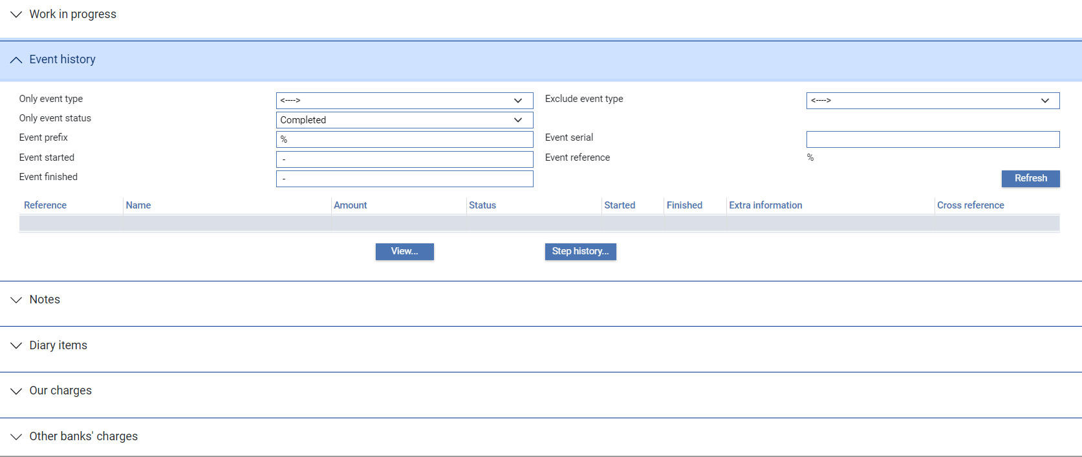

For more information on how the various panes and buttons in this window work see the Common Facilities User Guide – Trade Innovation.

# Acknowledgement

This chapter explains how to use the system to handle acknowledgement of an undertaking.

## Acknowledgement in Trade Innovation

You can use the Receive Acknowledgement event to view details of an acknowledgement you have received or enter details of an acknowledgement to be sent. You can create either a response to that message or a new message within the same event.

If your bank receives an acknowledgement via SWIFT, it uses it to create a Receive Acknowledgement event at an Input step for the appropriate undertaking.

To record an acknowledgement message, in the Master Summary window select 'Receive Acknowledgement' from the Create New Event drop-down list. The system opens the event at either a Log step or Input step. Depending on how your system is configured, panes and fields available in log steps can be tailored for each data capture step. See the *SDK - Screen Tailoring User Guide* – Trade Innovation for details.

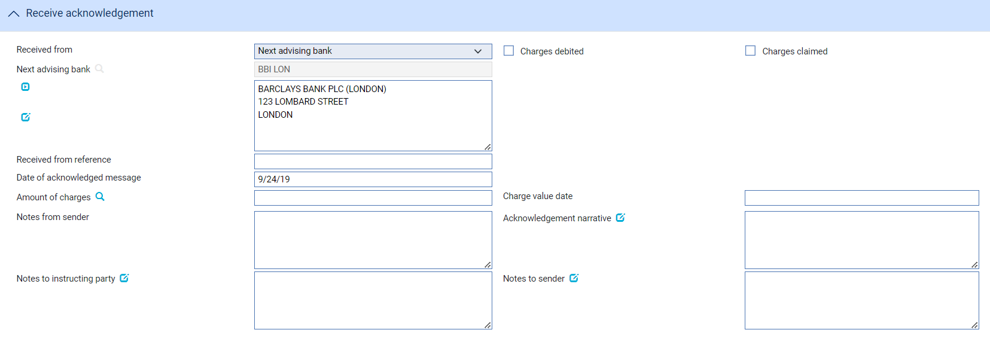

The default for the Received From party is the non-principal party

Use the Received From Reference field to enter the Received From party's reference for the undertaking and the Narrative field to enter any narrative associated with the response. The Charges Claimed and Charges Debited boxes permit you to indicate, if appropriate, whether the advising bank is claiming or has debited its charges. You cannot check both of these boxes, but you can leave them both blank.

Use the Date of Acknowledged Message field to enter the date your bank received the acknowledgement.

# Paying a Demand Against a Received Undertaking

This chapter explains how to use the system to record the presentation of documents and to select the required payment action for an Undertaking, including continuing claims that are left unpaid as a result of requesting payment. It also explains how to enter details of additional amounts, margin deposits and assignments of proceeds against payments.

For information on payment actions, including additional bank defined actions and their effect on charges see the Appendix.

For information on repaying a financing loan from within a payment event see the Financing User Guide – Trade Innovation.

## Presentations and Requests for Payment

When the beneficiary or bank presents documents for payment, the system includes a Documents Presented event that allows you to proceed in various ways, depending on the state of the documents presented:

* *Pay or Request payment* - If the documents are in order, you can either make the payment or request payment, then send the documents presented and details of any payment made to the issuing bank.
* *Request to Pay or Extend* – This is used where the beneficiary gives the applicant to opportunity to extend the undertaking rather than paying the demand. If the response is to *Extend* then the undertaking expiry date is extended.
* *Other* options. The bank can define the payment additional actions for other business scenarios. If there are discrepancies in the documents:
* You can advise the presenting party that this is the case, and then request missing documents or return the documents to the presenting party and request re-presentation
* You can request authority from the issuing bank to make payment. When the issuing bank replies you can proceed with the payment, refuse it, or reject it, depending on whether authority has been given or not. The Outstanding Presentation event (see page 39) allows you to continue a claim that has been pended in this way
* If the discrepancies are only minor, you can pay the beneficiary, with the caveat that, should the documents be refused by the issuing bank that the payment will be recoverable from the presenting party

Each payment amount allocated to an assignment can be discounted as part of the payment event, if required. However, it cannot be discounted later, once the payment event has completed.

### Assignments of Proceeds

During payment events the system permits you to set up new assignments for the transaction, and to access details of assignments already set up and allocate proceeds to them.

Each payment amount allocated to an assignment can be discounted as part of the payment event, if required. However, it cannot be discounted later, once the payment event has completed.

### Licenses

If there is a license attached to a revolving transaction, the license amount must be sufficient to cover the maximum amount available under the transaction - that is, the transaction amount plus the maximum tolerance - multiplied by the number of revolving cycles.

See the Licenses User Guide – Trade Innovation for details of licenses.

### Financing Transactions

If your system has the financing module implemented, then while processing a payment the Finance pane will be available.

This allows you to record a financing transaction against the payment, as described in the Financing User Guide – Trade Innovation.

You can also repay a financing transaction from within the payment event.

## Payment at Maturity

For claims whose payment action was ‘Pay at Maturity’ (or ‘Accept’ ) the system creates an outstanding payment event in the diary to handle the payment at the time of maturity. When the maturity date is reached the system processes the event during overnight processing. The event may require input or review and/or authorisation, in which case the system places the event in the Work in Progress pane for you to complete.

When you open an outstanding payment event for a maturity payment the system displays the relevant response type.

## Document Presentation

To record the presentation of documents for a Received Undertaking, in the Master Summary window select 'Documents Presented' from the Create New Event drop-down list. The system opens the event at either a Log step or Input step depending on how the Workflow orchestration controlling the event is configured. See the *Workflow Tailoring User Guide* – Trade Innovation for details.

### Recording details of the Demand

If your system has been configured to have a log step as part of your workflow the system will display a Log window allowing you to enter basic details of the Demand.

The Input step uses the following panes:

* The Received Undertaking Details pane (see page 32)
* The Demand Details pane (see page 33)
* The Payment Action pane (see page 35)
* The Payment Details pane (see page 36)
* The Additional Amounts pane (see page 38)
* The Associated Payment Details pane (see page 38)
* The Instructions pane (see page 38)
* The Documents/Notes pane
* The Other Beneficiary Bank pane (see page 39)

For instructions on using the fields in the Documents/Notes pane to identify any documents being presented see the Common Facilities User Guide – Trade Innovation.

#### The Received Undertaking Details Pane



This provides some of the key details relevant to payment of the undertaking – read only.

#### The Demand Details Pane

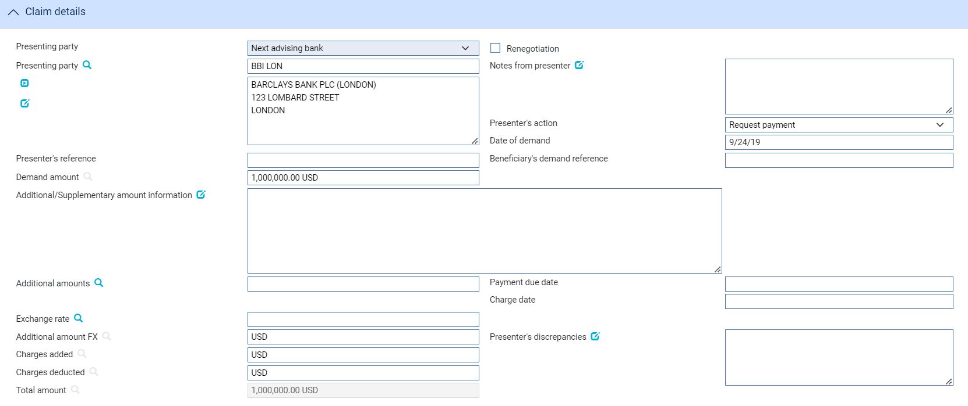

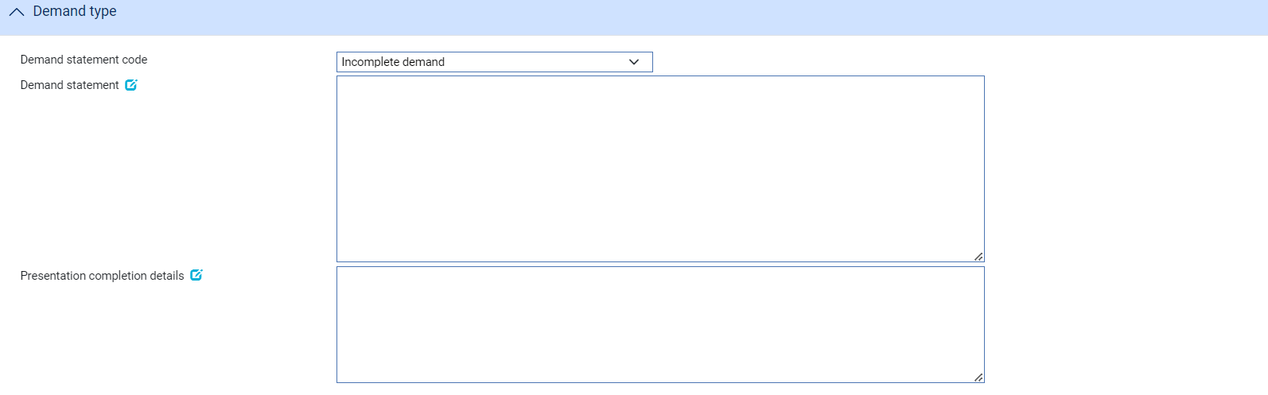

The following table explains what to enter into the Claim Details pane:

|  | Field | What to Enter |
| --- | --- | --- |
|  | Presenting Party | You can use the first field to select a party already identified in the event using their party role, in which case their details are retrieved and displayed in the remaining fields in this pane.  Alternatively, if the presenting party has not been assigned a party role within the transaction, select 'Other presenting party' in the first field, then use the remaining fields to enter their details in the usual way. If you identify a party in this way, they are assigned the role of 'Presenting party'.  The system uses the advising bank as the default, or the beneficiary, if the undertaking was advised direct. |
|  | Renegotiation | Indicates whether the Demand is a renegotiation |
|  | Notes from Presenter | Any notes or instructions received from the presenting party. |
|  | Presenter’s action | Choose one of the following values from the drop-down list to indicate what action the presenter has taken with regard to the Demand:   * Request Payment * Request Pay Or Extend * Request Authorisation to Pay * Pay and Claim Reimbursement * Request Acceptance * Sender has Debited our Account * Documents Sent On Approval * Other  1. The items in the list are configured by your bank and so may differ from the list above. |
|  | Date of Demand | The date of the presentation. The system uses today's date as the default. |
|  | Presenter's Reference | The presenter's reference for the Demand |
|  | Beneficiary’s demand reference | The beneficiary’s reference for the Demand |
|  | Requested new expiry date | The requested new expiry date where the demand is to *Request Pay Or Extend* |
|  | Presentation Amount | The system displays either the available amount of the undertaking (less any outstanding claims) or the presentation amount, if entered during a Log step. |
|  | Presentation Currency | The currency of the presentation amount, if different from the currency of the undertaking |
|  | Additional Amounts | Any additional amounts being claimed. |
|  | Payment Due Date | The date payment is due, or the value date used to debit your account with the presenting bank. |
|  | Charge Date | The value date for any charges taken separately. |
|  | Exchange rate | Exchange rate where additional amounts are in a different currency |
|  | Additional amount FX | Exchange rate to convert the additional amounts to undertaking currency |
|  | Charges added | The value and currency of any charges that the sender has informed you have been added to the payment amount. For complete reconciliation check that this amount is equal to the charges due to the presenting party. |
|  | Charges deducted | The value and currency of any charges that the sender has informed you have been deducted from the payment amount. For complete reconciliation check that this amount is equal to the charges due from the presenting party. |
|  | Total Amount | The system calculates the total amount being claimed and then displays it in this field. |
|  | Presenter’s Discrepancies | If the action involves a request for authorisation to pay, use this field to enter details of any discrepancies advised by the presenter or any notes in the supporting documents. |
|  | Demand statement code | Select whether the Demand is *Complete* or *Incomplete* |
|  | Demand statement | Details of the Demand |
|  | Presentation completion details | Where the demand is Incomplete enter further details of how the presentation documents will be completed |
|  | Transfer by/File name | The type of delivery channel and associated file name or reference. |

#### The Payment Action Pane

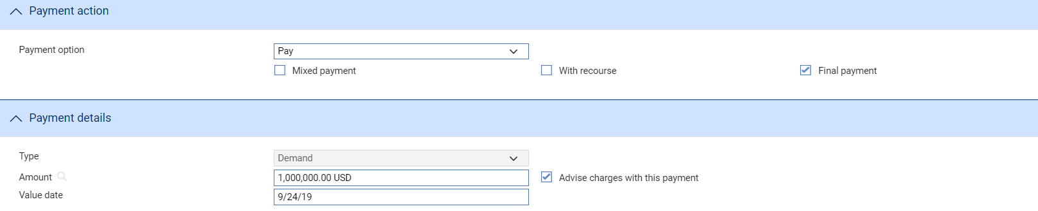

See the Appendix for a list of payment actions.

The Payment Action pane allows you to process the Demand by selecting a payment action and then entering details of the payment.

The actions included in the Payment Option drop-down list vary, depending on whether the undertaking was a direct presentation by the beneficiary, and on the presenter's actions, for example whether they are requesting pay or extend, authorisation to pay or whether instead they have paid and are requesting reimbursement.

Normally for a Demand payment, details of the actual payment are entered into the Payment Details pane. However, if a mixed payment is required, to involve two or more part payments, check the Mixed Payment field. The system displays a Payments pane, which you can use to enter details of each of the part payments in turn.

Check the With Recourse box if the payment is with recourse; and the Final Payment box if the payment includes the final payment under the reimbursement authority.

If your payment action is 'Reject and Claim Refund' then enter the date of the refund into the Refund Date field.

The payment action you select applies to all part payments. However, where the action is 'Pay' the individual status of a payment can be changed using the Pay Status field in the Payment Details window.

Note that:

* If you enter any part payment details, the value of all part payments must not exceed the value of the letter of credit, and must reconcile with the claimed amount
* Where the payment action for an individual part payment is 'Pay at Maturity' (or 'Accept'), the system creates a diary event which will cause an Outstanding Presentation event to be generated automatically at the appropriate time to allow that part payment to be matured

If the payment action is 'Pay' for a future dated payment, acceptance or deferred payment, the system generates the postings and funds movements for the future date, and no separate future Outstanding Presentation event takes place. The forward-dated postings are held by the system until the value date is reached, then posted during batch processing.

* If the payment action is *'Request Approval from Issuing Bank'*, the system displays an additional field - Reasons for Authorisation request - in the Instructions To Send pane.
* Where the payment action is a *Request to Pay or Extend* or *Extend* an additional expiry date field is displayed



* Where the payment action is *Extend* the system automatically creates an Amend event on release of the payment event.

1. The system is delivered with a standard set of ‘Presenter’s actions’ and ‘Payment actions’ which will typically cover the required processing for claims and documentary presentations. However, depending on your bank’s internal processes and requirements, it may be necessary to create additional Presenter’s and Payment actions that are more appropriate to your workflow.

Where this is required, your bank can use System Tailoring to define its own Parameter set based Presenter's actions and Payment actions for Received undertakings and additionally, create Transfer presenter's actions and Response actions as required. A code and description can be entered for each of these actions together with the associated underlying payment ‘behaviour’ type, such as *General request, Pay, Request to Pay or Extend, Extend, Reject, or Pay at maturity* which then determines the subsequent processing of the payment when the action is selected.

See the System Tailoring User Guide – Trade Innovation for instructions on defining additional payment actions.

#### The Payment Details Pane

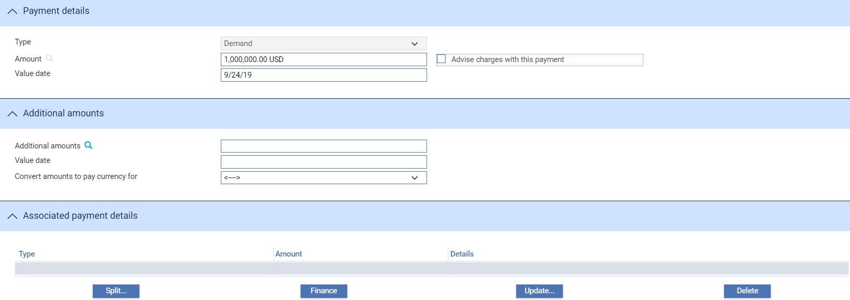

The Payment Details pane allows you to enter details of the payment you are making.

The Payment type is normally set to Demand for a received undertaking.

Where an existing master has an associated payment types of Sight, Deferred, Acceptance then the relevant screen is shown allowing the details to be entered or changed to Demand. However, once changed to Demand the payment type can no longer be changed.

For mixed payment, check the Mixed Payment field in the Payment Action pane. A new pane - the Payments pane - is displayed.

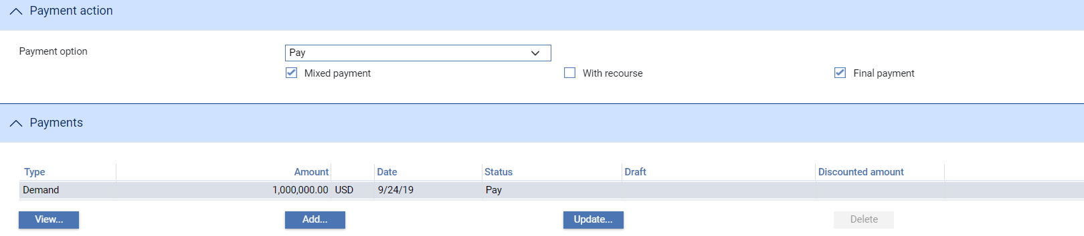

Select the payment listed in this window and click the **Update** button. In the window that appears, define the first part payment.

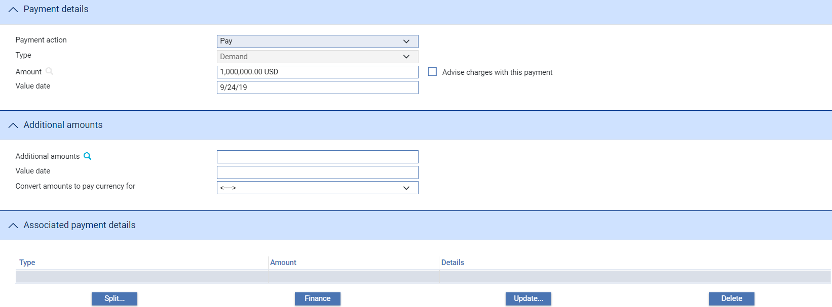

The fields are the same as those used in the Payment Details pane to define a single payment. When you close the window, the details of the part payment are listed in the Payments pane, from where you can select them and amend or delete them. Use the **Add** button to reopen the window to enter details of the next part payment.

Once you have entered details of a payment, or part payment, it is listed in the Payments pane.

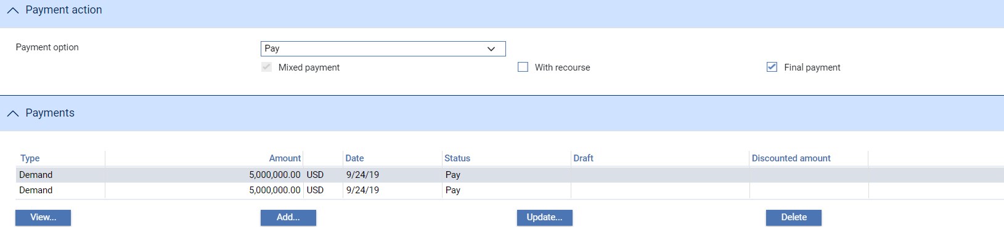

1. The system creates a first part payment for the full amount of the payment event. If you add more part payments, amend the amount of this first part payment accordingly.

The following table explains what to enter to define a payment or part payment:

| Field | What to Enter |
| --- | --- |
| Payment Action | This field is displayed only for mixed payments, and it initially reflects the payment action selected for the Demand in the main Input window. If the payment action involves refusal or leaves the claim outstanding, then you will not be able to alter the value in this field.  If the payment action involves paying the claim, then you can use this field to select a status for each individual part payment.  Select from the available options. |
| Type | Set to Demand. (Sight, Deferred or Acceptance may be displayed where an existing master is not *Available by* Demand allowing additional details to be entered such as the tenor period, draft id, hold and eligible). |
| Amount | The amount being claimed. |
| Advise Charges with This Payment | Check this box if charges taken or claimed are to be advised with this payment. |
| Value Date | For Demand or Sight payments, enter the value date of the payment.  For Acceptance and Deferred payment the value date of the payment is calculated using the value in the Period field.  The system issues a warning if this date does not leave enough time for any pre-debit notification required. |
| Start Date/Period/From/ After | For acceptance and deferred payments, the start date of the payment period.  Use the Period field to define the period (as, for example, 1 month or 10 days), then use the From/After field to indicate whether the period will be calculated from or after the base date. |
| Draft Identifier | If there is a draft identifier, enter it here. |
| Hold | This field is displayed for sight and acceptance payments. Check it if drafts are being held, and uncheck it if they are being returned to the claimant.  You can discount a draft only if this and the Eligible box are checked. |
| Eligible | This box must be checked for you to be able to discount a part payment. For sight and acceptance payments, the Hold box must also be checked. |

#### The Additional Amounts Pane



The following table explains what to enter into the fields in the Additional Amounts pane:

|  |  |
| --- | --- |
| Field | What to Enter |
| Additional Amounts | Any additional amount. |
| Value Date | The value date of any additional amount. |
| Margin Amount For | Where relevant, the amount to be taken as a margin deposit. |

#### The Associated Payment Details Pane

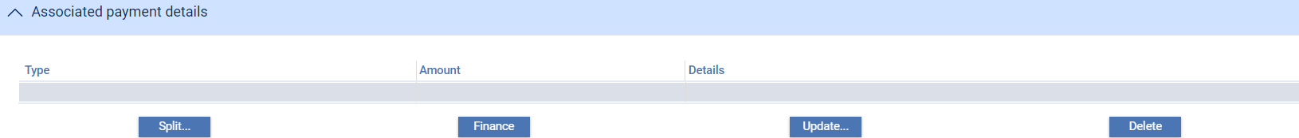

The Associated Payment Details pane allows you to apply further processing against the payment or part payments being made. As payments are entered they are listed in this pane. You can select them individually and enter details of a loan or discount or license drawdown.

See Chapter Processing Additional Payment Details for instructions on using this pane to apply further processing against the payment or part payments being made.

#### The Instructions Pane

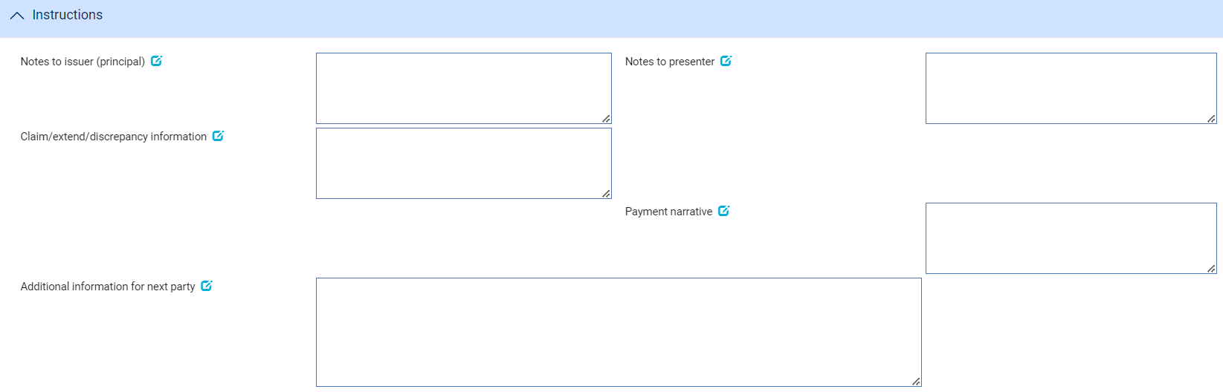

The Instructions pane allows you to enter notes for the issuer and the presenter.

Depending on the setting of the system option DiscrepancyFieldAlwaysVisible the Document Discrepancies field may be displayed here, even if the payment action would not normally require it to be populated. When the system option is switched on the field allows you to enter minor discrepancies for your bank's own audit purposes, where the payment action does not normally involve reporting discrepancies.

#### The Documents Pane

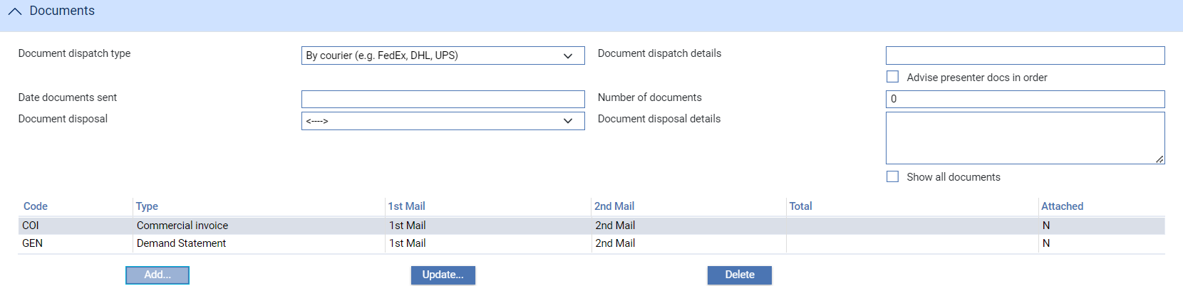

For instructions on using the fields in the Documents/Notes pane to identify any documents being presented see the Common Facilities User Guide – Trade Innovation.

The buttons in this pane allow you to identify the documents required by or received against a transaction; and to subsequently view, amend or delete those documents

#### The Other Beneficiary Bank Pane

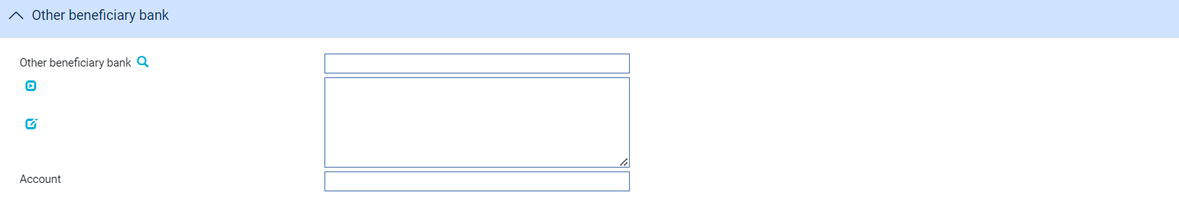

The fields in the Other Beneficiary Bank pane allow you to identify the bank you want the issuing bank to pay, if other than your own bank, and the number of the account to be credited.

## Continuing a Demand

If you select a payment action during the Documents Presented event which involves postponing payment whilst awaiting a reply, for example until you have received Payment, a Pay or Extend response or other Authorisation to pay response from the issuing bank, the Outstanding Presentation event allows you to continue the claim.

To continue the claim, in the Master Summary window select 'Outstanding Presentation' from the Create New Event drop-down list. The system opens the event at either a Log step or Input step depending on how the Workflow orchestration controlling the event is configured for your bank. See the *Workflow Tailoring User Guide* – Trade Innovation for details.

### Selecting the Presentation to Continue

If there is only one outstanding claim, the system retrieves it and displays its details. If there is more than one outstanding claim, you must use the **Select** button to select the one to continue. When you click this button the system displays the Select Payment Event window.

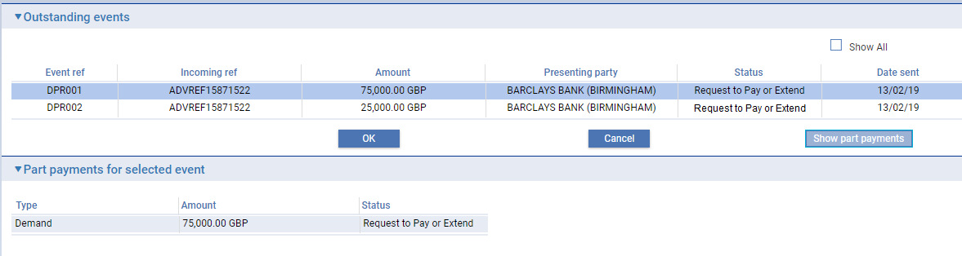

This window lists all completed payment events that have not been paid. The window does not show any claims currently in progress. If you check the Show All box, the system also includes in the list all completed Documents presented and Outstanding Presentation events that have been paid in full or been rejected.

If you check the Show All box, the system also includes in the list all completed payment events that have been paid in full or been rejected. You can initiate an outstanding presentation event against a completed presentation event in order to issue general correspondence or to reject a previously-paid presentation.

You can view details of the drafts associated with a claim by selecting the event and clicking the **Show Part Payments** button.

When you select an event and then click the **OK** button, the system closes the window and displays information taken from that event.

### Entering the Full Details of a Response

The table below lists the fields shown for the response details for the outstanding presentation.

If your system has been configured to have a log step as part of your workflow the system will display a Log window allowing you to enter basic details of the response received.

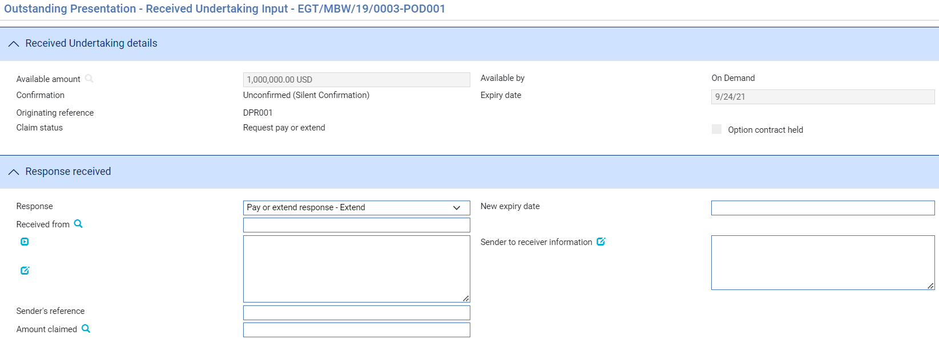

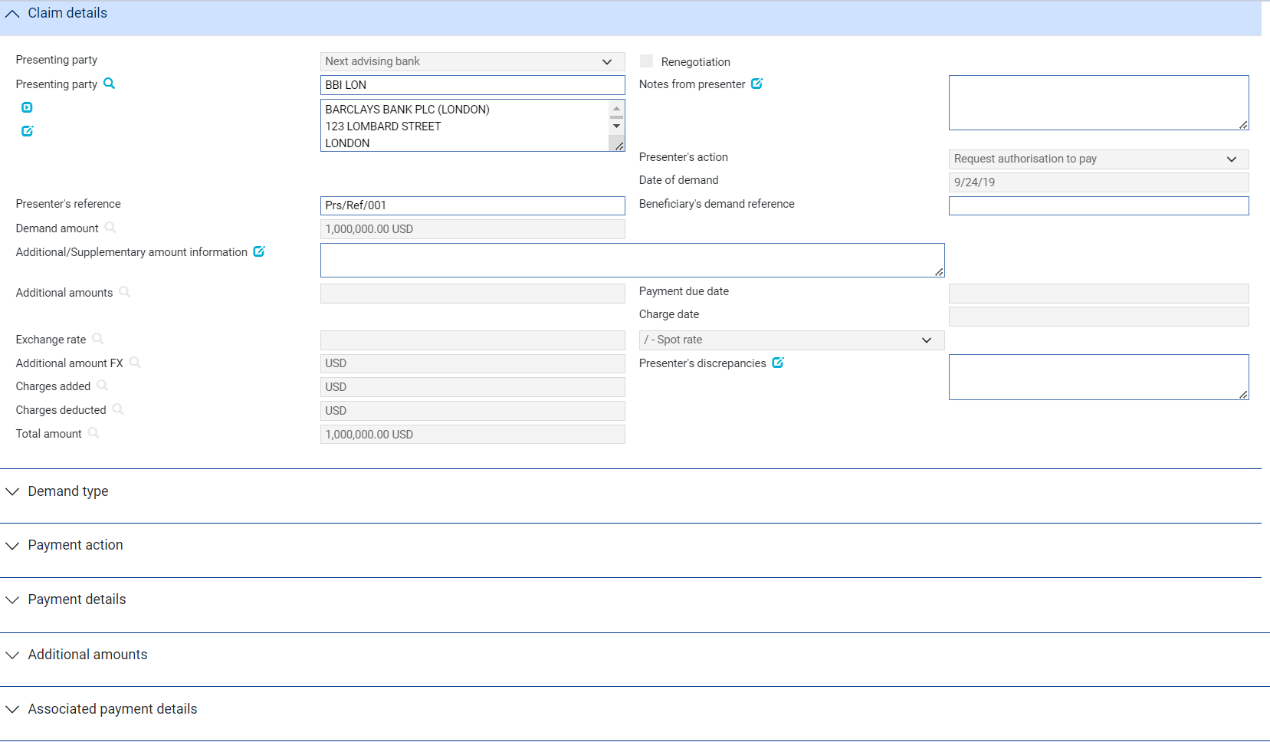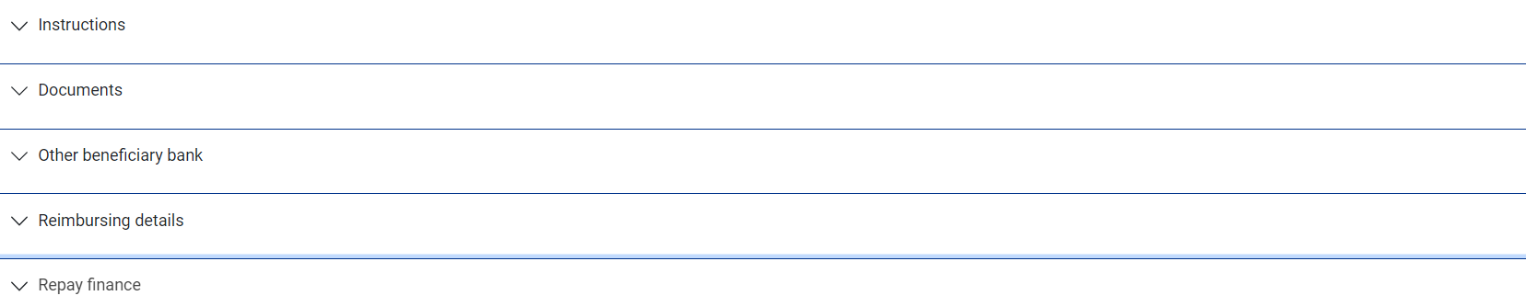

If there is only one outstanding claim, the system retrieves it and displays its details. If there is more than one outstanding claim, use the **Select** button (see page 39) to select the one to continue.

Use the Received From field to identify the party from whom you received the response, and enter their reference for the response into the Sender's Reference field.

The Response field allows you to identify the type of response received.

You can select from the following values:

* Advice of Payment (see page 42)
* Pay or Extend Response – Pay
* Pay or Extend Response - Refusal
* General (see page 42)
* Documents Received (see page 42)
* Advice of Discharge (see page 42)
* Refusal (see page 44)
* Authorisation to Pay (see page 45)
* Invoices Received (see page 42) for transfer letters of credit
* Maturity (see page 32) if the event has been generated automatically from a diary action
* Reverse Payment (see page 46)

Once you have selected the response, click **Refresh**. The fields shown in the window vary, depending on what response type you select.

#### Advice of Payment

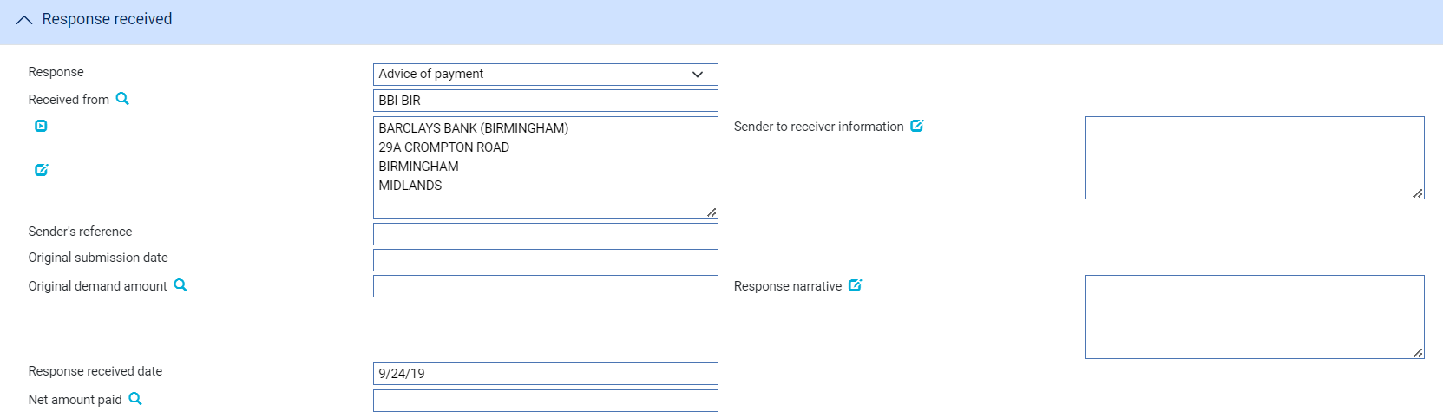

The following table explains what to enter into the fields displayed when you select 'Advice of Payment':

|  |  |
| --- | --- |
| Field | What to Enter |
| Sender to Receiver Information | Any narrative from the sender. |
| Original Submission date | The date of the original Demand |
| Original Demand amount | The amount claimed on the original Demand |
| Response Received Date | The date on which you received the response. |
| Response narrative | Response narrative |
| Net Amount Paid | The net amount being paid by the sender of the message. |

#### Pay or Extend Response – Pay

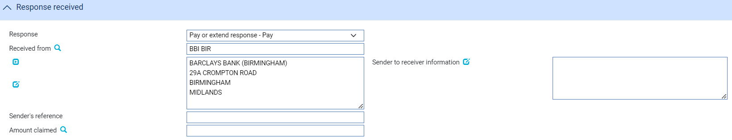

The following table explains what to enter into the fields displayed when you select a Pay or Extend response of *Pay*:

|  |  |
| --- | --- |
| Field | What to Enter |
| Sender to Receiver Information | Any narrative from the sender and sender’s reference |
|  |  |
| Amount claimed | The amount claimed on the original Demand |

#### Pay or Extend Response – Extend

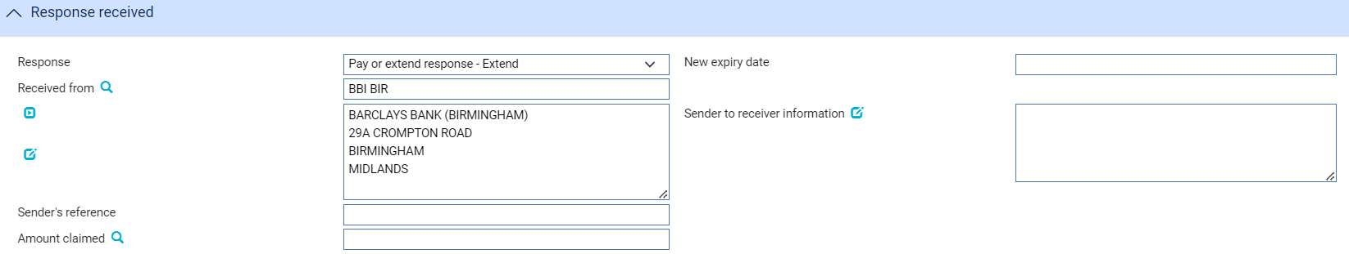

The following table explains what to enter into the fields displayed when you select a Pay or Extend response of *Extend*:

|  |  |
| --- | --- |
| Field | What to Enter |
| New Expiry Date | The new expiry date to which the undertaking is to be extended |
| Sender to Receiver Information | Any narrative from the sender and sender’s reference |
|  |  |
| Amount claimed | The amount claimed on the original Demand |

#### General/Documents Received/Invoices Received

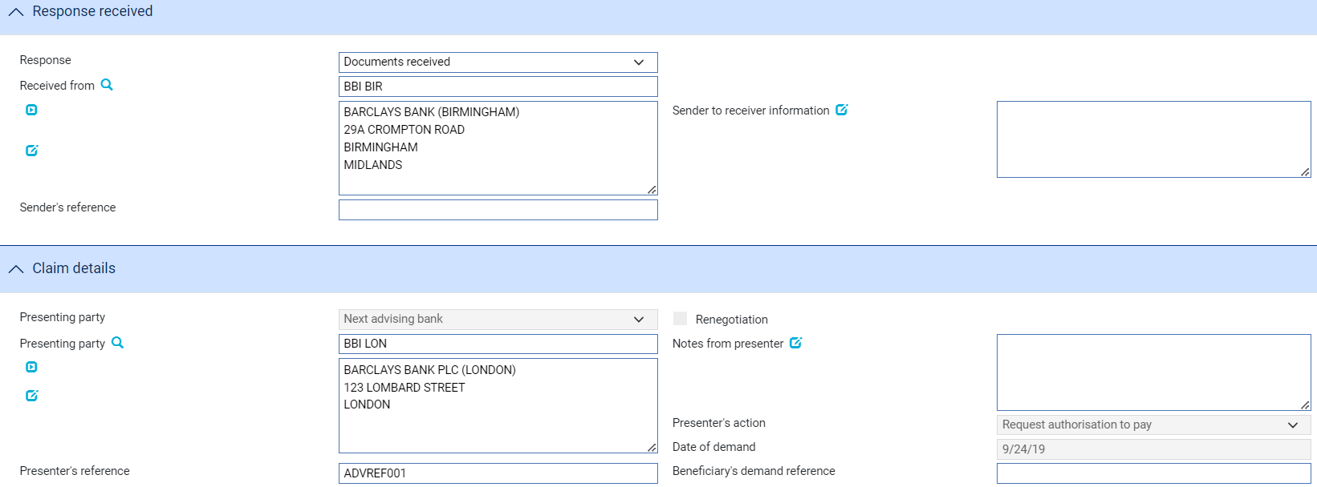

If you select 'General', 'Documents Received' or 'Invoices Received', you can use the Sender to Receiver Information field to enter any narrative from the sender. If you select 'Documents Received', you should also enter details of the documents received in the Documents/Notes pane.

#### Advice of Discharge

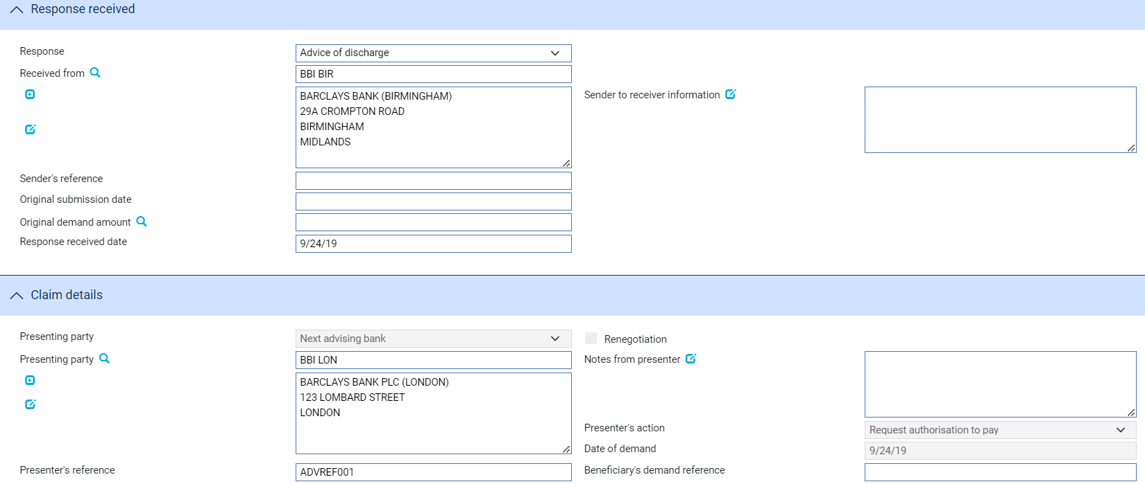

The following table explains what to enter into the fields displayed when you select 'Advice of Discharge':

|  |  |
| --- | --- |
| Field | What to Enter |
| Sender to Receiver Information | Any narrative from the sender and sender’s reference |
| Original Submission date | The date of the original Demand |
| Original demand amount | The amount claimed on the original Demand |

#### Refusal

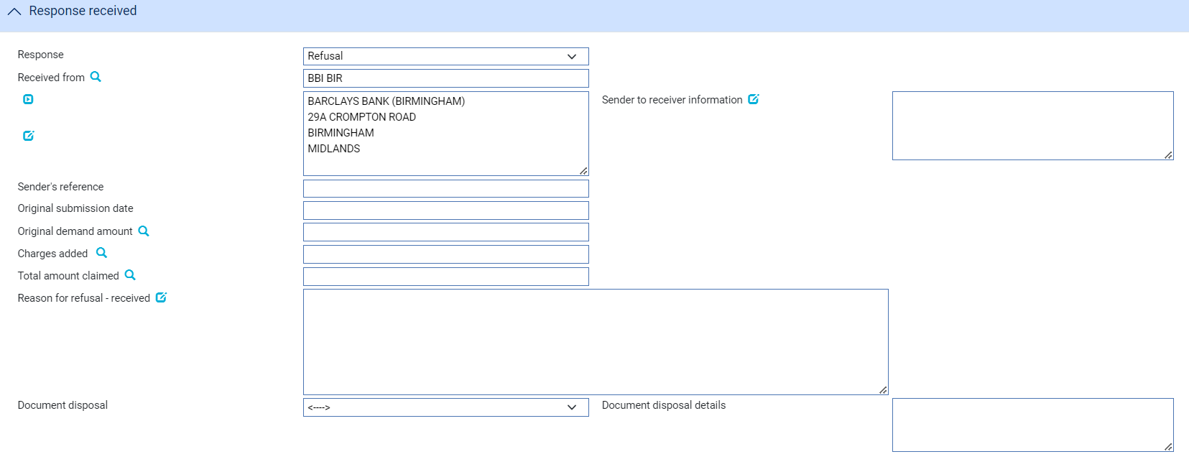

The following table explains what to enter into the fields used to record refusal:

| Field | What to Enter |
| --- | --- |
| Sender to Receiver Information | Any narrative from the sender |
| Original Submission date | The date of the original Demand |
| Original demand amount | The amount claimed on the original Demand |
| Charges Added | Any charges (with currency) being claimed by the sender as the result of refusing the claim. These represent other bank’s charges due from the seller. |
| Total Amount Claimed | The total amount (with currency) being claimed for refund. This is the total of the original amount plus any charges added. |
| Reason for Refusal - received | Narrative giving the reason for the refusal received from the sender. |
| Disposal of Documents | Use this dropdown to indicate the disposal action for the documents. Choose either   * Hold - If you intend to hold documents received pending further instructions * Notify – If documents are to be held until the issuing bank receives a waiver from the applicant and agrees to accept it, or receives further instructions from the presenter prior to agreeing to accept a waiver * Return - If documents are refused and are to be returned to the sender * Previous instructions – Acting in accordance with instructions previously received from the presenter |
| Document disposal details | Additional information related to the disposal of documents |

Use the Document Disposal field in the Documents pane to indicate what is to be done with the documents.

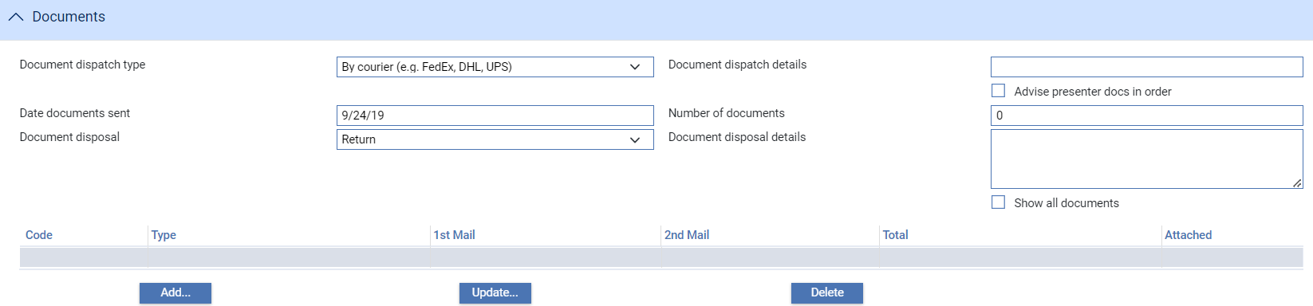

#### Authorisation to Pay

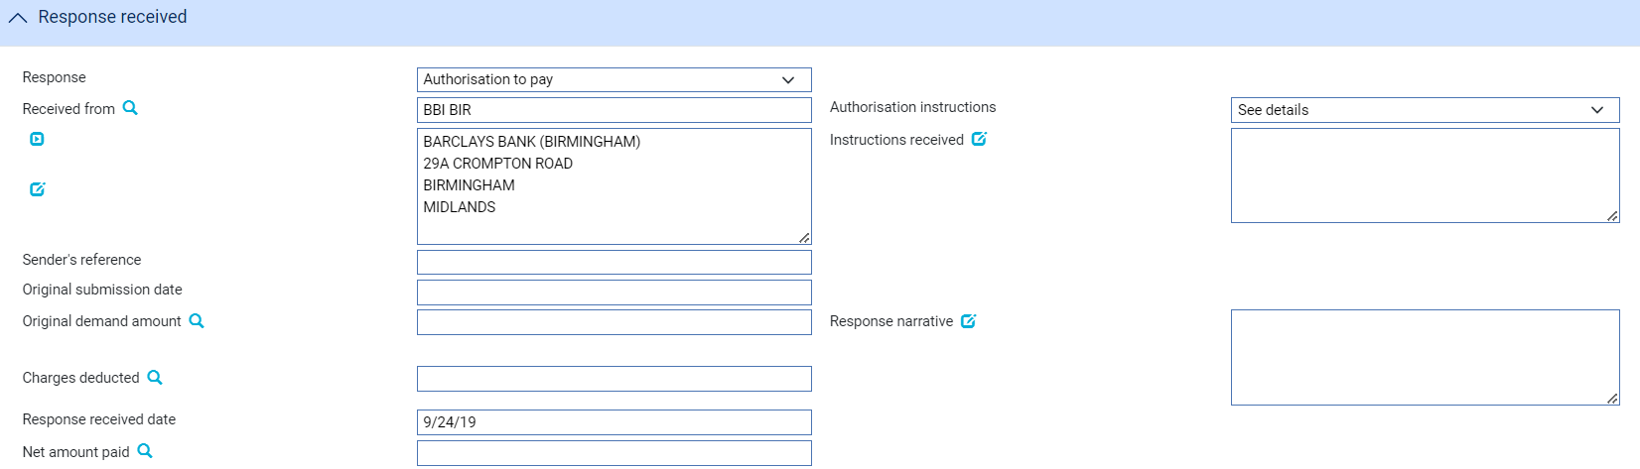

The following table explains what to enter into the fields displayed when you select 'Authorisation to Pay':

| Field | What to Enter |
| --- | --- |
| Authorisation Instructions | Use the first field to select from one of the following:   * Accept * Debit Selves * Pay and Claim Reimbursement * See Details * Negotiate   In the Instructions Received field enter narrative describing the terms of authorisation. |
| Original Submission date | The date of the original Demand |
| Original Demand amount | The amount claimed on the original Demand |
| Charges Deducted | Any charges being deducted by the sender. For complete reconciliation check this amount using the Charges Summary window. See the Common Facilities User Guide – Trade Innovation for instructions. |
| Net Amount Paid | The net amount being paid. |
| Response Narrative | Additional notes to the presenter |

#### Reverse Payment

The ‘Reverse Payment’ payment action allows a payment to be refunded where, for example, a claim is initially paid but is subsequently found to be discrepant. The payment action is available only when a transaction is flagged as having multiple payments, with a single part payment that has already been paid.

When this payment action is selected, the part payment that has already been paid is set to ‘Paid/Reversed’.

Your bank will need to define postings to reverse the part payment. This might involve the reinstatement of any liability, if appropriate.

# Renewing an Undertaking

This chapter explains how undertakings are renewed, and renewals advised, in the system using the Renewal and Advise Renewal events.

## Renewals in Trade Innovation

When you first enter details of an undertaking on your system, the system permits you to define a schedule to determine when, how often and for how much (the original amount of the undertaking or its current amount) the undertaking is to be renewed for. If the customer requires a renewal advice, you can also specify how soon before the renewal happens the advice is to be produced.

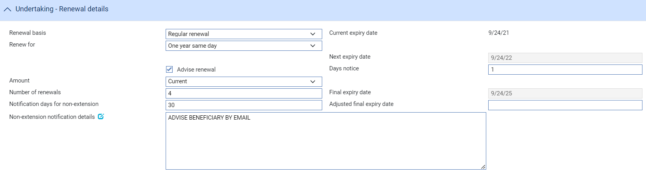

The system also allows you to define the number of days prior to the final expiry date that the beneficiary should be advised of that the undertaking will not be extended together with details on how the beneficiary should be notified.

For information on the diary facility see the Common Facilities User Guide – Trade Innovation.

The system uses this schedule to create diary entries for the undertaking which automatically generate the renewal advice and renew the undertaking on the appropriate dates.

The system uses two events to handle renewal advices, non-extension notifications and renewals:

* To generate the renewal advice or non-extension notification, the system uses the Advise Renewal event (see page 48)
* To generate the renewal itself, the system uses the Renewal event (see page 49)

Each of these two events can be configured to be generated and released automatically, requiring no manual intervention. Alternatively, they may be configured so that they require review and/or authorisation before they can be released, in which case the system generates an event at the Review step and lists it in the Work in Progress pane in the Summary window.

Upon release of the Renewal event, the system updates the expiry date of the undertaking and creates a new diary event for expiry, for production of the next renewal advice and for the next renewal itself, as appropriate.

If your bank has implemented credit limit checking, then, if a Renew event is configured to be generated automatically during overnight processing and an overline condition is reported, the Renew event will be generated at the Approval step in the Work in Progress pane.

### Licenses

If there is a license attached to the undertaking, then there may be additional validation during the renewal event:

* If the original amount is renewed, there must be sufficient available amount on the license
* If amount available on the license is insufficient for the renewal, you can attach new licenses to the transaction and make further reservations
* If the license expires at renewal, you may attach a new license

See the Licenses User Guide – Trade Innovation for details of licenses.

### Participated Deals

If the undertaking is participated and is being renewed for the original amount, renewal may result in a Drawdown/Revolve Commit Amt event being created as a subsidiary event.

## Reviewing and Authorising a Renewal Advice

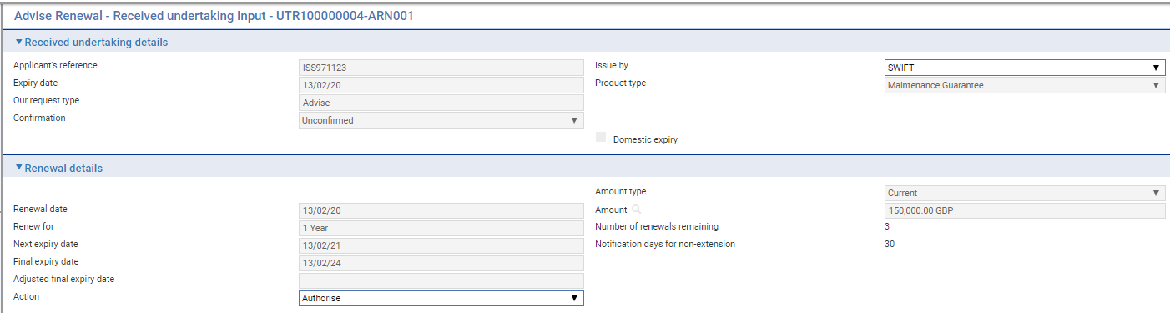

The following table lists the fields in the window used to review Advise Renewal events, explaining what they show and what to enter into those fields that permit input:

| Field | What it Shows |
| --- | --- |
| Applicant's Reference | The applicant's reference for the undertaking. |
| Issue By | The method used to send the renewal advice. |
| Product Type | The type of undertaking. |
| Expiry Date | The expiry date of the undertaking. |
| Our Request Type | The bank’s request type |
| Confirmation | The confirmation status of the undertaking, either Confirmed, Unconfirmed or May Add |
| Domestic Expiry | This box is checked if the expiry is domestic, and blank if the expiry is overseas. |
| Amount Type | Indicates whether the undertaking is being renewed at the original amount or the current amount. |
| Renewal Date | The date on which the undertaking is to be renewed. |
| Amount | The amount of the undertaking after renewal. |
| Renew For | The renewal period. |
| Number of Renewals Remaining | The number of renewals remaining. |
| Next Expiry Date | The new expiry date of the undertaking. |
| Final expiry | The calculated final expiry date |
| Adjusted final expiry date | Adjusted final expiry |
| Notification days for non-extension | The notice period for advising non-extension |
| Action | This field is used to either authorise or reject the renewal advice.  If you reject an Advise Renewal event, the reduction or increase itself still occurs when it is due. |

When the Event is released the *Extra information* displays the Authorisation or Rejection of the Renewal advice as follows:

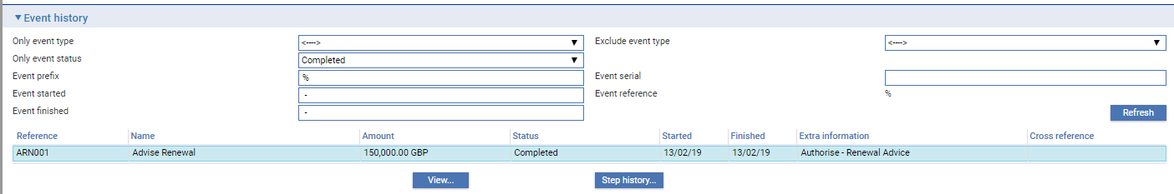

## Non-Extension Notification Renewal advice

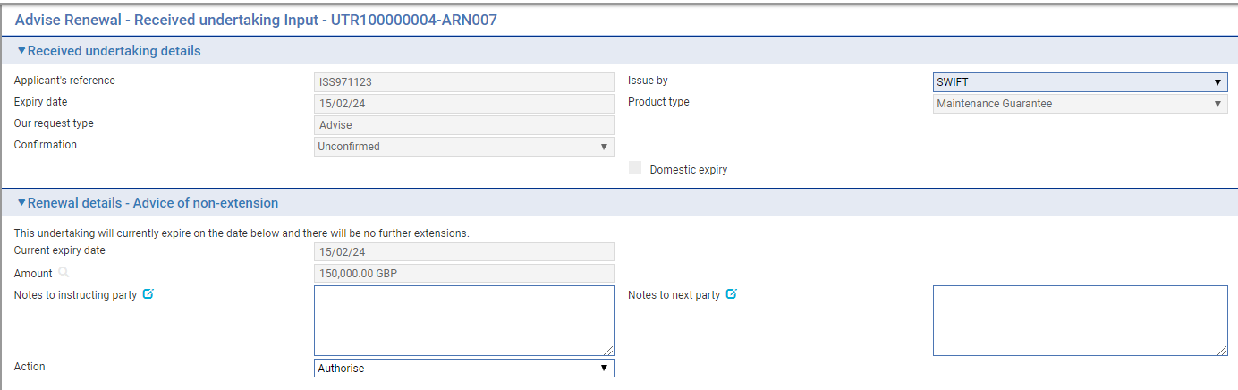

The following table lists the fields in the window used to review Advise Renewal events, explaining what they show and what to enter into those fields that permit input:

| Field | What it Shows |
| --- | --- |
| Applicant's Reference | The applicant's reference for the undertaking |
| Issue By | The method used to send the renewal advice |
| Product Type | The type of undertaking |
| Expiry Date | The expiry date of the undertaking |
| Our Request Type | The bank’s request type |
| Confirmation | The confirmation status of the undertaking, either Confirmed, Unconfirmed or May Add |
| Domestic Expiry | This box is checked if the expiry is domestic, and blank if the expiry is overseas. |
| Non-extension details | Text ‘This undertaking will currently expire on the date below and there will be no further extensions’ |
| Notes to Instructing Party | Notes to instructing party |
| Notes to Next Party | Notes to next party |
| Action | Allows the user to Approve or Reject the Renewal |

When the Event is released the *Extra information* displays the Authorisation or Rejection of the Renewal advice as follows:

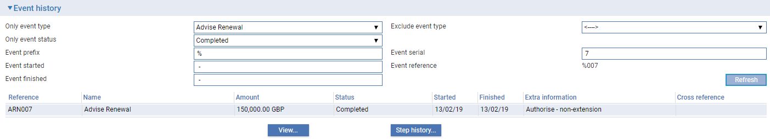

## Reviewing and Authorising a Renewal

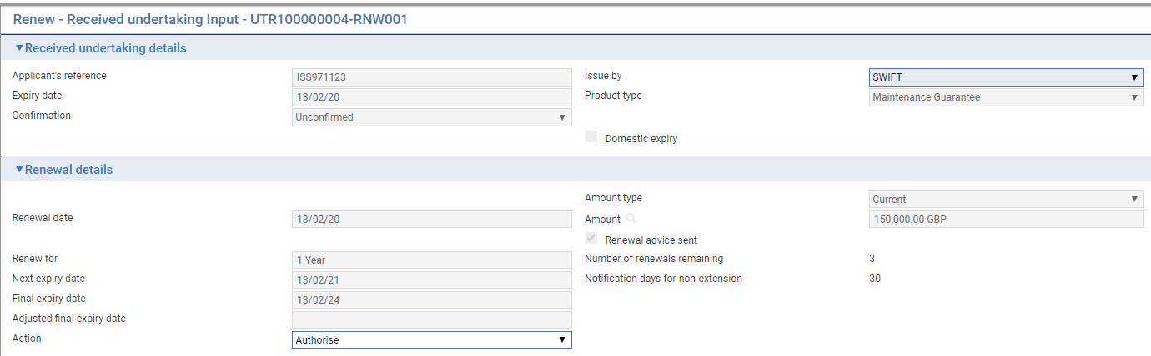

The following table lists the fields in the window used to review and authorise Renewal events, explaining what they show and what to enter into those fields that permit input:

| Field | What it Shows |
| --- | --- |
| Applicant's Reference | The applicant's reference for the undertaking. |
| Issue By | The method used to send the advice. |
| Expiry Date | The expiry date of the undertaking. |
| Product Type | The type of undertaking. |
| Our Request Type | The bank’s request type |
| Confirmation | The confirmation status of the undertaking, either Confirmed, Unconfirmed or May Add: |
| Domestic Expiry | This box is checked if the expiry is domestic, and blank if the expiry is overseas. |
| Amount Type | Indicates whether the undertaking is being renewed at the original amount or the current amount. |
| Renewal Date | The date on which the undertaking is to be renewed. |
| Amount | The amount of the undertaking after renewal. |
| Renewal Advice Sent | This field is checked if a renewal advice has been sent for this renewal. |
| Renew For | The renewal period. |
| Number of Renewals Remaining | The number of renewals remaining. |
| Next Expiry Date | The new expiry date of the undertaking. |
| Final expiry | The calculated final expiry date |
| Adjusted final expiry date | Adjusted final expiry |
| Notification days for non-extension | The notice period for advising non-extension |
| Action | Allows the user to Approve or Reject the Renewal |

When the Event is released the *Extra information* details the Authorisation or Rejection of the Renewal as follows:

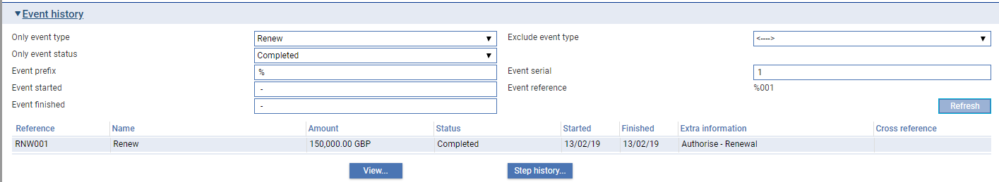

# Reducing and Increasing Undertakings

This chapter explains how undertakings are reduced and increased, and any such changes advised in the system using the Reduction/Increase and Advise Reduction/Increase events.

For information on the diary facility see the Common Facilities User Guide – Trade Innovation.

## Reductions and Increases

When you first enter details of an undertaking on your system, the system permits you to define a schedule to determine when, how often and by how much (as a fixed amount or a percentage of the original value of the undertaking) the undertaking is to be reduced or increased. If the customer requires an advice of the reduction or increase, you can also specify how soon before the reduction or increase happens the advice is to be produced. The system uses this schedule to create diary entries for the undertaking which automatically generate the advice and reduce or increase the undertaking on the appropriate dates.

The system uses two events to handle advices and reductions or increases:

* To generate the advice, it uses the Advise Reduction/Increase event (see page 53)
* To generate the reduction or increase itself, it uses the Reduction/Increase event (see page 54)

Each of these two events can be configured to be generated and released automatically, requiring no manual intervention. Alternatively, they may be configured so that they require review and/or authorisation before they can be released, in which case the system generates an event at the Review or Authorise step and lists it in the Work in Progress pane in the Master Summary window.

If your bank has implemented credit limit checking, then, if a Reduction/Increase event is configured to be generated automatically during overnight processing and an overline condition is reported, the event will be generated at the Approval step in the Work in Progress pane.

### Licenses

If there are reductions on an undertaking that has a license attached, you may reinstate the unutilised reserved license amount.

If there are increases on an undertaking that has a license attached, the additional amount plus the original amount will be validated against the license amount available. You have the option of adding new licenses and making further reservations, as necessary. The system will also re-check the license validity date.

See the Licenses User Guide – Trade Innovation for details of licenses.

### Participated Deals

If the undertaking is participated, an increase may result in a Drawdown/Revolve Commit Amt event being created as a subsidiary event, to reduce the commitment amount available on the participation deal. Similarly, a reduction may result in a Drawdown/Revolve Commit Amt event being created to increase the commitment amount available on the participation deal, if the deal is revolving.

## Reviewing and Authorising a Reduction/Increase Advice

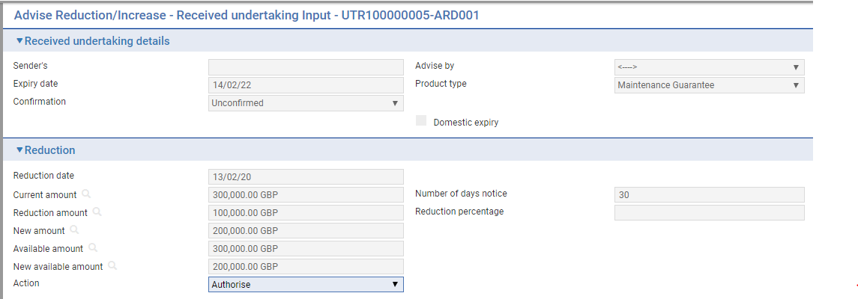

The following table lists the fields in the window used to review and authorise Advise Reduction/Increase events, explaining what they show and what to enter into those fields that permit input:

|  |  |
| --- | --- |
| Field | What it Shows |
| Sender’s reference | The applicant's reference for the undertaking. |
| Advise By | The method used to send the advice. |
| Expiry Date | The date of the undertaking. |
| Product Type | The type of undertaking. |
| Confirmation | The confirmation status of the undertaking, either Confirmed, Unconfirmed or May Add |
| Domestic Expiry | This box is checked if the expiry is domestic, and blank if the expiry is overseas. |
| Reduction/Increase Date | The date on which the undertaking is to be reduced or increased. |
| Current Amount | The current amount of the undertaking. |
| Increase/Reduction Amount | The amount of the reduction or increase. |
| New Amount | The amount of the undertaking after the reduction or increase has been applied. |
| Available Amount | The available amount and currency of the undertaking,before the reduction or increase takes place. |
| New Available Amount | The available amount of the undertaking after the reduction or increase has taken place. |
| Number of Days Notice | Indicates how many days before the reduction or increase takes place the advice is to be produced. |
| Reduction/Increase Percentage | The amount of the reduction or increase, expressed as a percentage of the original undertaking amount. |
| Action | Click on one of the choices in this pane to either authorise the event or to reject it.  If you reject an Advise Reduction/Increase event, the reduction or increase itself still occurs when it is due. |

## Reviewing and Authorising a Reduction or Increase

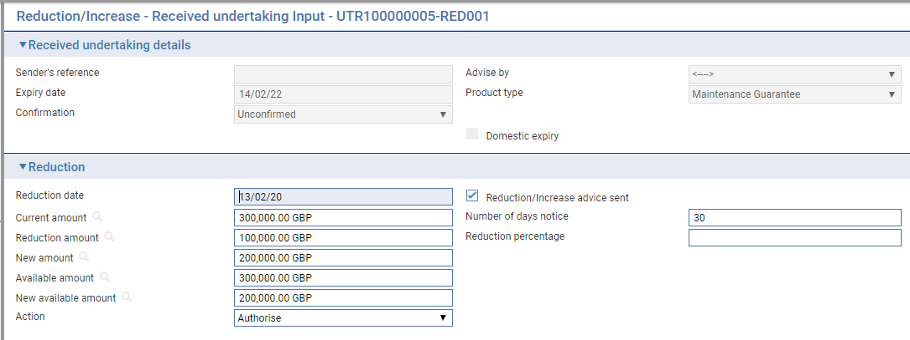

The following table lists the fields in the window used to review and authorise Reduction/Increase events, explaining what they show and what to enter into those fields that permit input:

|  |  |
| --- | --- |
| Field | What it Shows |
| Sender's Reference | The applicant's reference for the undertaking. |
| Advise By | The method used to send the advice. |
| Expiry Date | The expiry date of the undertaking. |
| Product Type | The type of undertaking. |
| Confirmation | The confirmation status of the undertaking, either Confirmed, Unconfirmed or May Add |
| Domestic Expiry | This box is checked if the expiry is domestic, and blank if the expiry is overseas. |
| Reduction/Increase Date | The date on which the undertaking is to be reduced or increased. |
| Reduction/Increase Advice Sent | This field is checked if an advice of the reduction/increase has been sent. |
| Current Amount | The current amount of the undertaking. |
| Increase/ Reduction Amount | The amount of the reduction, and its currency. |
| New Amount | The amount of the undertaking after the reduction or increase has been applied. |
| Available Amount | The available amount and currency of the undertaking, before the reduction or increase takes place. |
| New Available Amount | The available amount of the undertaking after the reduction or increase has taken place. |
| Number of Days Notice | Indicates how many days before the reduction or increase takes place an advice is to be produced. |
| Reduction/Increase Percentage | The amount of the reduction or increase, expressed as a percentage of the original undertaking amount. |
| Action | Click on one of the choices in this pane to either authorise the event or to reject it. |

# Making Changes to a Received Undertaking

This chapter explains how to use the system to make amendments to a received undertaking and, where necessary, to record beneficiary approval for the amendment.

It also describes how to use the Adjust event to make other changes to the master record.

## Amendments in Trade Innovation

An undertaking can be amended using an Amend event (see page 59) at any time between the release of the Advise event and book-off.

Typically, an amendment will be initiated by the issuing bank at the request of the applicant. The issuing bank then passes details of the amendment on to the next bank in the processing chain, which will record the details and then inform the next advising bank or the beneficiary, as appropriate.

If beneficiary approval is not required for the amendment, then accounting entries and changes to the master record as a result of the amendment are carried out as soon as the Amend event has been released.

If the beneficiary's approval is required for the amendment, then the amendment does not take effect until the beneficiary's approval has been obtained and recorded in the system using a Beneficiary Response to Amend event (see page 60). If this is the case, then no accounting entries are produced for the Amend event, although any charges due can be paid, if required. Once beneficiary approval has been recorded using a Beneficiary Response to Amend event, then the appropriate accounting entries are made once the Beneficiary Response to Amend event has been released. If beneficiary approval is required, then the changes made during the amendment are not applied to the master record until beneficiary approval has been obtained.

If the amendment increases the amount of an undertaking that is already participated, a Drawdown/Revolve Commit Amt event may be created as a subsidiary event to decrease the commitment amount available on the participation deal. If the amendment decreases the amount of an undertaking that is already participated, a Drawdown/Revolve Commit Amt event may be created as a subsidiary event to increase the commitment amount available on the participation deal, if the deal is revolving.

You can also use an Amend event to reinstate an expired or cancelled undertaking's master record.

1. If you amend the expiry date of an undertaking that has rolling renewal based on the expiry date, you will need to amend the rolling renewal schedule manually.

### Reversal Postings

You can use the reversal posting facilities to set up the necessary postings to handle amendments which may have an effect on any previous liability accounting, such as changes to confirmation instructions or the tenor of a payment.

### Licenses

If the master record is attached to a license, the License pane is available for you to view and amend any details of additional reservations or reinstatements when the amount or currency change.

There will also be some additional validation when you make an amendment to a master attached to a license. For example:

* If you make an amendment after the Valid To date on the license has passed, the system will either reject the amendment or allow a new license to be added, depending on how your system has been set up
* If you change the shipment date, the new shipment date must be between the Valid From and Valid To dates on the license
* If you change the amount or currency, the new value will be validated against those on the license. The license amount may be reserved or reinstated for the amended amount

1. If you are increasing the amount of a master record, then a reservation is automatically made against the license. If you are decreasing the amount, then a reinstatement is automatically made. If you change the If you are increasing the amount of a master record, then a reservation is automatically made against the license. If you are decreasing the amount, then a reinstatement is automatically made. If you change the currency, you may reinstate in the old currency and make a reservation in the new currency (assuming that the license in question allows multiple currencies).

If the master record is amended so that its status changes from Cancelled or Expired, the reinstated letter of credit value will be validated against the available amount on the license.

If the amendment requires beneficiary approval then any reservations or drawdowns required occur in the Ben Response to Amend event instead, provided that the amendment is approved.

See the Licenses User Guide – Trade Innovation for details of licenses.

### Maintaining Liability

You can change the way that liability on a transaction is shared by using the Maintain Liability event. Maintain Liability events can be used to:

* Participate a transaction
* Share customer liability on a transaction

When you click the OK button or the Pend button on the Input window of an Amend event for a participation deal, a Maintain Liability subsidiary event is automatically generated for each transaction affected by the amendment. You can use the Subsidiary Events link from the Master Summary window to view this event but it is processed and released via the participation deal Amend event.

See the Participated Deals User Guide – Trade Innovation for the Maintain Liability event.

### Handling More than One Amendment at a Time

The system permits you to have more than one Amend event in progress at the same time. If you attempt to open an Amend event for a master record that already has an Amend event in progress, or is awaiting the beneficiary's response to an amendment, the system will warn you of the fact, but will allow you to continue. The system will show the current details held for the master when the Amend event is created or opened at an Input step.

You can check whether any changes have been made to master record details between an Amend event requiring beneficiary approval being initiated and that approval being received. The Beneficiary Response to Amend event allows you to display a list of master record fields, and indicates in this list any fields where the information held on the master record differs from that held in the Beneficiary Response to Amend event. Should you discover a field that has been updated since the Amend event was initiated, you can choose whether or not to overwrite the value currently held in the master record with the value held in the Beneficiary Response to Amend event.

A field - the Use Previously Amended Amounts in Advise field - present during the Amend event when a previous amendment is still awaiting beneficiary approval permits you to decide whether or not the amount shown in tag 34b of the MT707 advice should take into account the amount of the earlier amendment.

If your system is configured so that Amend events need to be reviewed and/or authorised before release, then during these later steps the supervisor will be advised of the existence of another Amend event that has completed while the current event has been at the Review or Authorise step. They can then decide how each Amend event should be handled to ensure that the required changes are implemented.

## Displaying Changes

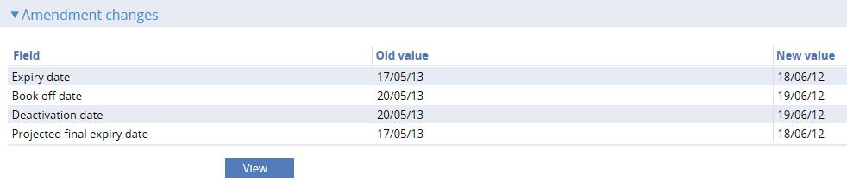

When making amendments or adjustments to a transaction the Changes button allows you - and reviewers and authorisers - to list those fields that have changed within the event. It opens a window that lists those fields whose value has changed and shows for each the value before the current event and the new value resulting from the event.

For free-format narrative fields, your bank can configure the system so that it shows either the entire content of the field in the New Value column, or just a certain number of lines (defined by the system option ViewChangesLineCount) followed by the text:

>>> plus n more lines. 'View' for details.

where n is the number of additional lines not displayed.

Selecting that entry in the list and clicking the **View** button displays the entire content of the field.

This window is displayed automatically when the event is opened for review or authorisation.

1. If you work with this window open, use the **Refresh** button to update the display to show any changes made since you opened the window.

When entering the beneficiary's response to an Amend event, the Changes button permits you to check whether any master record details have changed since the amendment event was initiated.

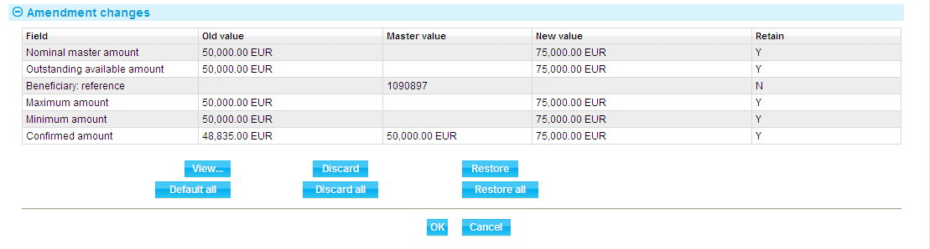

It lists those fields whose value has changed and shows for each:

* The value before the event was initiated (Old Value)
* The new value resulting from the change made in the event (New Value)

If another event has taken place since the amendment event was initiated which has changed the value of fields held on the master record, the current value of those fields (Master Value). If this field is blank, no intervening change in value has taken place.

You can see any changes made by clicking the **View** button.

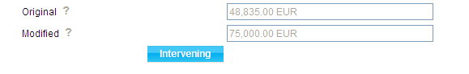

The window displayed allows you to see any intervening changes made by clicking the **Intervening** button.

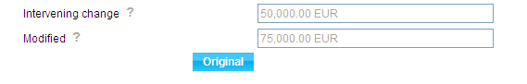

## Amending a Received Undertaking

To amend an undertaking received, in the Master Summary window select 'Amend' from the Create New Event drop-down list and click **Create**. The system opens the event at either a Log step or Input step. Depending on how your system is configured, panes and fields available in log steps can be tailored for each data capture step. See the *SDK - Screen Tailoring User Guide* – Trade Innovation for details.

The Amendment request details can be entered as follows:

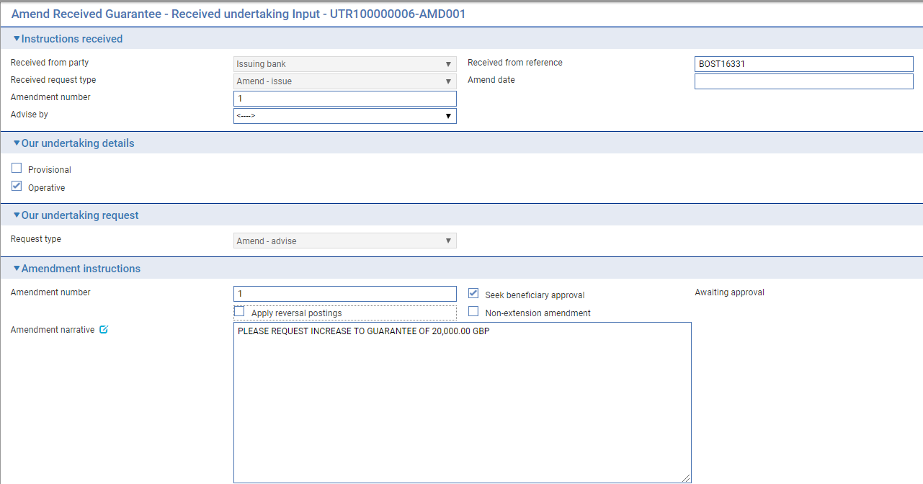

The **View Event Changes** button on the menu bar allows you to display any changes that have been made to the master.

The following table lists additional fields displayed and explains what to enter into them:

| Field | What to Enter |
| --- | --- |
| Received from party | Set to either the Issuing bank or Advising bank |
| Received from reference | Amendment reference |
| Received request type | Either *Amend- Issue* – if received from Issuing bank  or *Amend - Advise* or *Amend - Advice confirmed – if received from an Advising bank* |
| Amend Date | The date the amendment was created on your system. |
| Amendment number | Sender’s amendment number for this amendment |
| Advise by | Transfer method to be used to advise the amendment |
| Request type | The bank’s request type – either *Amend - Advise* or *Amend - Advice confirmed* |
| Amendment number | The bank’s own amendment number |
| Seek Beneficiary Approval | If the amendment requires beneficiary approval, check this field. |
| Apply Reversal Postings | Check this field if your bank has set up reversal postings for this event and wishes to apply them when the event is released. |
| Non-extension amendment | Used to indicate that the undertaking will no longer be extended beyond the current expiry date |
| Amendment Narrative | Any additional information about the amendment received from the instructing party . |

### Amending the Undertaking details

The Undertaking details are displayed as for the Advise event and the current details can be changed as required.

When entering amendment details:

* If you amend the expiry date of an undertaking that has rolling renewal based on the expiry date, you will need to adjust the rolling renewal schedule manually.
* If the amount of the undertaking has changed, you can enter the new amount in one of two ways:
* Use the Increase/Decrease field to select whether the change involves an increase or a decrease, then use the Increase/Decrease Amount to enter the value of the increase/decrease. When you click **Refresh**, the system calculates the amended amount and displays it in the Amount field
* Type the new amount into the Amount field
* The *Amendment details to send* field can be use to convey detail of amendments via the MT767 - Amendment to Demand Guarantee/Standby LC.

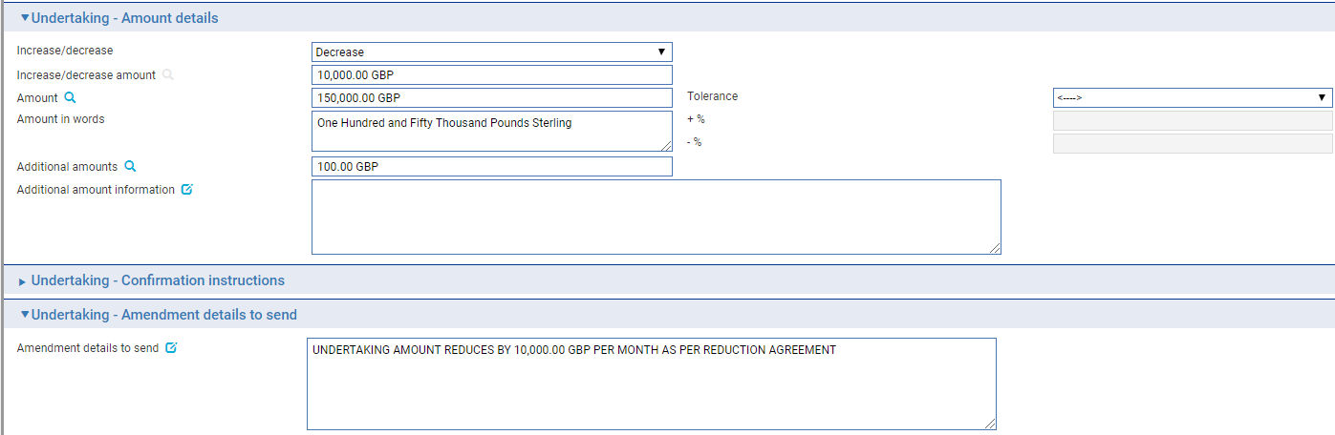

## Recording the Beneficiary's Response to an Amendment

If, when amending an undertaking you check the Seek Beneficiary Approval flag, then the amendment does not take effect until the beneficiary's approval has been obtained and recorded in the system.

To enter details of the beneficiary's response, in the Master Summary window select 'Beneficiary Response to Amend' from the Create New Event drop-down list and click **Create**. The system opens the event at either a Log step or Input step. Depending on how your system is configured, panes and fields available in log steps can be tailored for each data capture step. See the *SDK - Screen Tailoring User Guide* – Trade Innovation for details.

If there is only one amendment event awaiting a beneficiary response, the system retrieves it and displays its reference. If there is more than one amendment event awaiting beneficiary response, then the Select button permits you to select the one to which the beneficiary's response relates.

If there is only one amendment event awaiting a beneficiary response, the system retrieves it and displays its reference. If the undertaking has more than one amendment event awaiting beneficiary response, then the  button permits you to select the one to which the beneficiary's response relates.

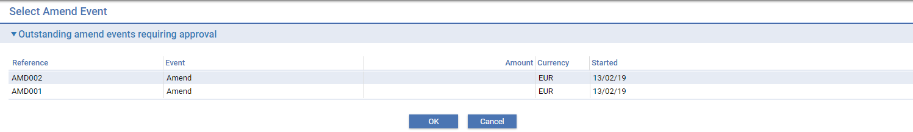

If Approved, the following details are shown allowing details of the Approval to be entered together with response notes to the instructing party and the received from bank

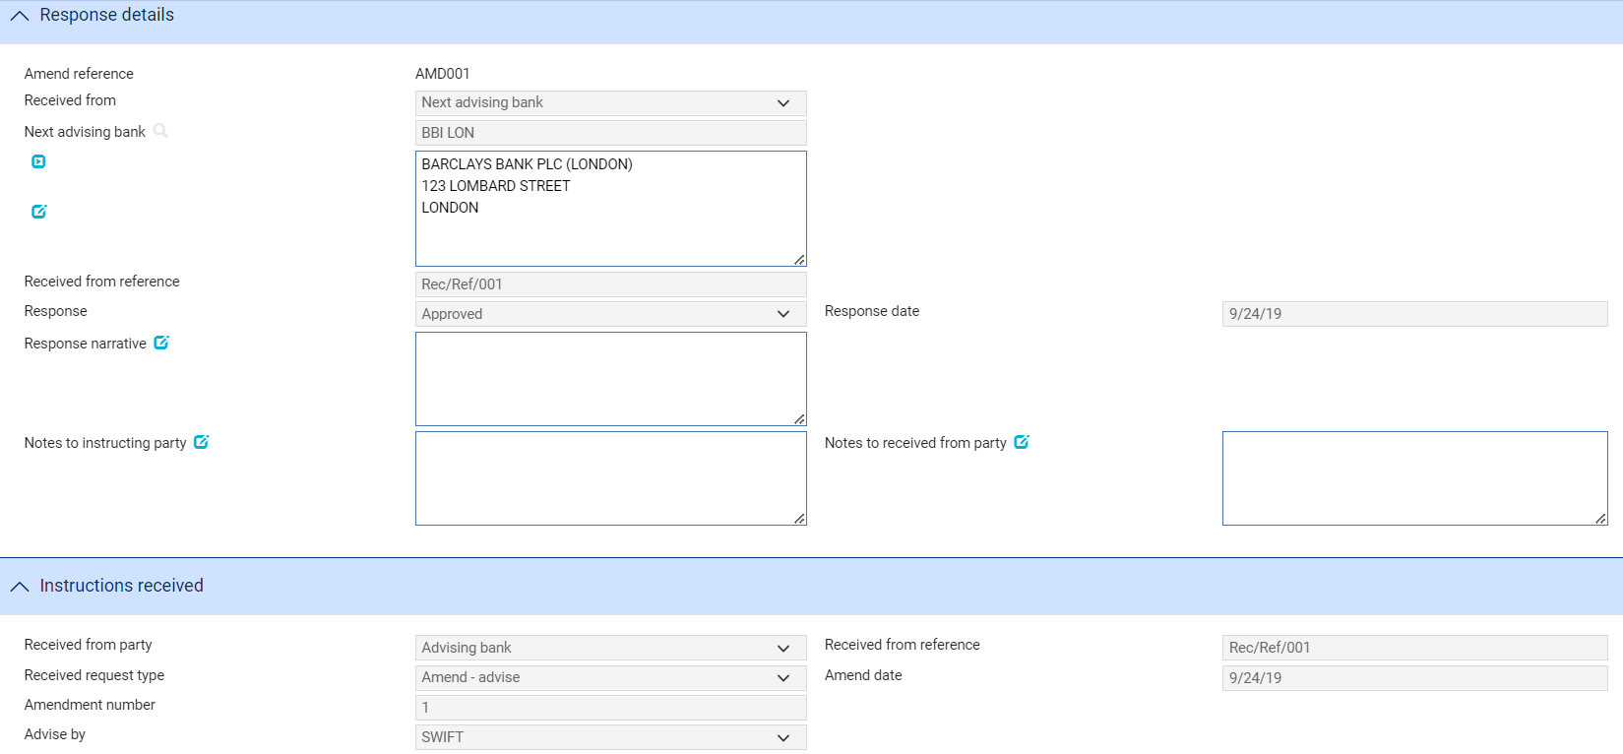

The **View Event Changes** button on the menu bar allows you to display any changes that have been made to the master.

If Rejected then an additional ‘Reasons for rejection’ fields is shown:

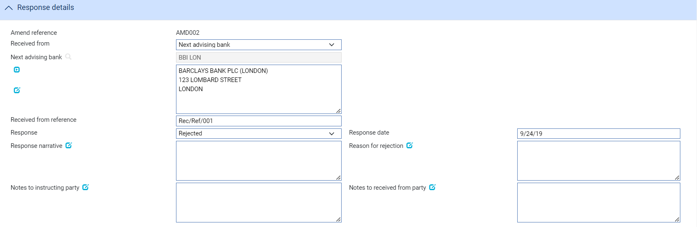

## Making Adjustments to the Master Record

The functionality of the Amend event allows you to make all the changes that are likely to be required in the normal course of business at the request of the applicant, and which may require beneficiary approval. the system includes an Adjust event, which contains additional functionality to allow you to make changes to all the information recorded for a transaction, with the exception of your bank's reference number for the transaction, and the status of a transaction's master record.

The Adjust event is designed to allow you to make changes where you need to alter details but do not need to notify other parties. This functionally is intended to allow you to correct mistakes, and should be used cautiously. If you make any changes using this functionality, you should ensure that the proper reconciliations are carried out.

1. Unlike the Amend event, the Adjustment event does require A sender’s amendment number to be recorded or a bank’s amendment number as all changed are internal to the bank’s processing.
2. Once you have initiated an Adjust event, the system will prevent you from opening any other event for the transaction until the Adjust event has completed. If you attempt to open an Adjust event while another event for the master is in progress, the system will warn you of the fact and prompt you to abort the Adjust event. Unless you are attempting to make an adjustment to allow the pre-existing event to complete, you should abort the Adjust event and wait until the pre-existing event has completed before attempting the Adjust event again. If you continue with the Adjust event, then the system will prevent any further work on the pre-existing event until the Adjust event has completed.

### Adjusting a Received undertaking

To adjust an undertaking, in the Master Summary window select 'Adjust' from the Create New Event drop-down list and click **Create**. The system opens the event at either a Log step or Input step. Depending on how your system is configured, panes and fields available in log steps can be tailored for each data capture step. See the *SDK - Screen Tailoring User Guide* – Trade Innovation for details.

The Adjustment details can be entered as follows:

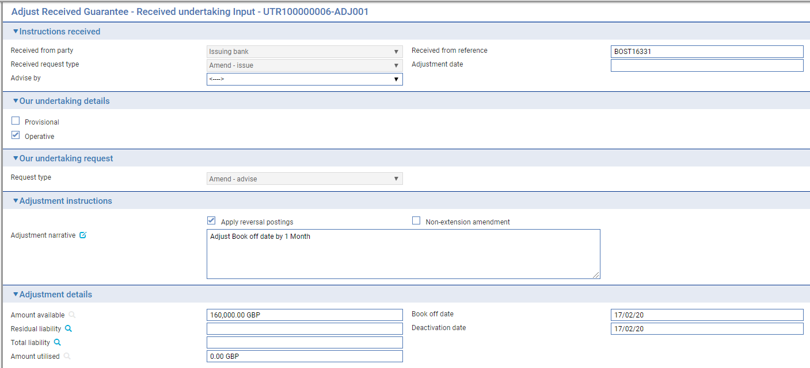

The remainder of the screen can be used to adjust any of the details related to the undertaking as for the amend event.

The **View Event Changes** button on the menu bar allows you to display any changes that have been made to the master.

The following table lists the adjustment fields displayed and explains what to enter into them:

|  |  |
| --- | --- |
| Field | What to Enter |
| Received from party | Set to either the Issuing bank or Advising bank |
| Received from reference | Adjustment reference ( if required) |
| Received request type | Either *Amend- Issue* – if received from Issuing bank  or *Amend - Advise* or *Amend - Advice confirmed – if received from an Advising bank* |
| Adjustment Date | The date the adjustment was created on your system. |
| Advise by | Transfer method to be used to advise the adjustment |
| Request type | The bank’s request type – either *Amend - Advise* or *Amend - Advice confirmed* |
| Apply Reversal Postings | Check this field if your bank has set up reversal postings for this event and wishes to apply them when the event is released. |
| Non-extension amendment | Used to indicate that the undertaking will no longer be extended beyond the current expiry date |
| Adjustment Narrative | Any additional information about the adjustment . |
| Amount Available | This field displays the amount outstanding on the undertaking. |
| Residual Liability | The system displays the outstanding liability amount as shown on the master record. Use this field to overwrite the figure shown on the master summary if, for any reason, the master figure is incorrect. |
| Total Liability | The system displays the outstanding liability amount as shown on the master record. Use this field to overwrite the figure shown on the master summary if, for any reason, the master figure is incorrect. |
| Amount Utilised | The amount of the undertaking utilised so far. |
| Book Off Date | The system displays the undertaking's book-off date, which you can amend. The system will then book off the undertaking when the new book-off date is reached. |
| Deactivation Date | The system displays the date on which the undertaking will become inactive (after its expiry date and any days grace period has elapsed). You can amend this date.  See the System Tailoring User Guide – Trade Innovation for the days grace period, which may be different for master records expiring locally and those expiring abroad. |

During an Adjust event you can view charges and add optional charges, but cannot edit existing charges. To change charges, use a Maintain Charges event.

# Cancelling a Received Undertaking

This chapter explains how to use the system to cancel an undertaking and, where necessary, to record beneficiary approval for the cancellation.

## Cancellations

An undertaking can be cancelled at any time after the release of the Advise event and book-off. However, you cannot cancel an undertaking on which there is work in progress.

Typically, cancellation will be initiated by the issuing bank at the request of the applicant. The issuing bank then passes details of the cancellation on to the next bank in the processing chain, which will record them and inform the next advising bank or the beneficiary, as appropriate.

The system provides:

* A Cancel event (see page 65), which allows you to record details of the cancellation. The Cancel event includes the facility to create messages to forward details of the cancellation
* A Beneficiary Response to Cancel event (see page 66), which allows you to enter and forward details of a beneficiary's response to a cancellation notification

If beneficiary approval is not required for the cancellation, then as soon as the Cancel event has been released, accounting entries are produced to reduce the liability and liability outstanding to nil and the master record is given the status CAN, although it is not removed from the system.

If a margin deposit was made to cover the undertaking then accounting entries are generated by the Cancel event to repay unutilised funds back to the customer's account.

If an undertaking that has a license attached is cancelled any unutilised amount reserved can be reinstated (provided that the Automatically Reinstate parameter has been set and a reservation had previously been made).

If the beneficiary's approval is required for the cancellation, then the cancellation does not take effect until the beneficiary's approval has been obtained and recorded using the system. If this is the case, then no accounting entries are produced for the Cancel event, although any charges due can be paid, if required. Once beneficiary approval has been recorded using a Beneficiary Response to Cancel event, then the appropriate accounting entries are made once the Beneficiary Response to Cancel event has been released. If beneficiary approval is required, and is not forthcoming, then the cancellation does not take effect.

1. A cancelled undertaking can be reinstated using the Amend event.

### Participated Deals

If a transaction is participated, cancelling it may result in a Drawdown/Revolve Commit Amt event being created as a subsidiary event to increase the commitment amount available on the participation deal, if the deal is revolving.

## Cancelling a Received Undertaking

With the appropriate master record open, in the Master Summary window select 'Cancel' from the Create New Event drop-down list and click **Create**. The system opens the event at either a Log step or Input step. Depending on how your system is configured, panes and fields available in log steps can be tailored for each data capture step. See the *SDK - Screen Tailoring User Guide* – Trade Innovation for details.

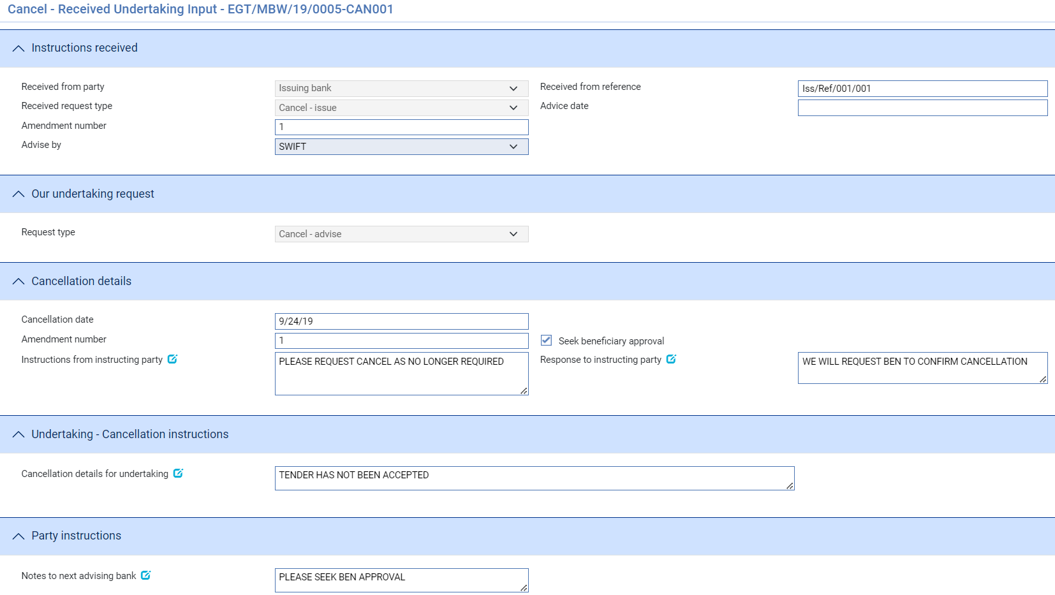

The following table lists these fields and explains what to enter into them:

| Field | What to Enter |
| --- | --- |
| Received from party | Set to either Issuing bank or Advising bank |
| Received from reference | Cancellation reference |
| Received request type | Either  *Cancel – Issue* – where received from issuing bank  *Cancel – Advise* or *Cancel – Advise confirmed* – where received from Advising bank |
| Advice date | Date of request received |
| Amendment number | Sender’s amendment number |
| Request type | The bank’s cancellation request type - Either  *Cancel – Advise* or  *Cancel -Advise confirmed* |
| Cancellation Date | The date when the cancellation takes effect. This defaults to today's date, but you can change it.  Any refunds to the customer are calculated with effect from the cancellation date. |
| Amendment number | The bank’s amendment number for this amendment |
| Seek Beneficiary Approval | Check this box if beneficiary approval is required for the cancellation. |
| Instructions from instructing party | Any instructions from the applicant regarding the cancellation. |
| Notes to instructing party | Response details to the instructing party |
| Cancellation details for undertaking | The reason for the cancellation. |
| Notes to next advising bank | Any instructions to the advising bank regarding the cancellation. |

## Recording the Beneficiary's Response to a Cancellation

If, when cancelling an undertaking you check the Seek Beneficiary Approval flag, then the cancellation does not take effect until the beneficiary's approval has been obtained and recorded in the system. The Beneficiary Response to Cancel event allows you to do this.

To enter details of the beneficiary's response, with the appropriate master record open, in the Master Summary window select 'Beneficiary Response to Cancel' from the Create New Event drop-down list and click **Create**. The system opens the event at either a Log step or Input step. Depending on how your system is configured, panes and fields available in log steps can be tailored for each data capture step. See the *SDK - Screen Tailoring User Guide* – Trade Innovation for details.

### Entering Full Details of the Beneficiary's Response

In the Beneficiary's Response pane, click on the appropriate field to indicate whether the beneficiary has approved or rejected the cancellation.

If Approved, the following details are shown allowing details of the Approval to be entered together with response notes to the instructing party and next advising bank

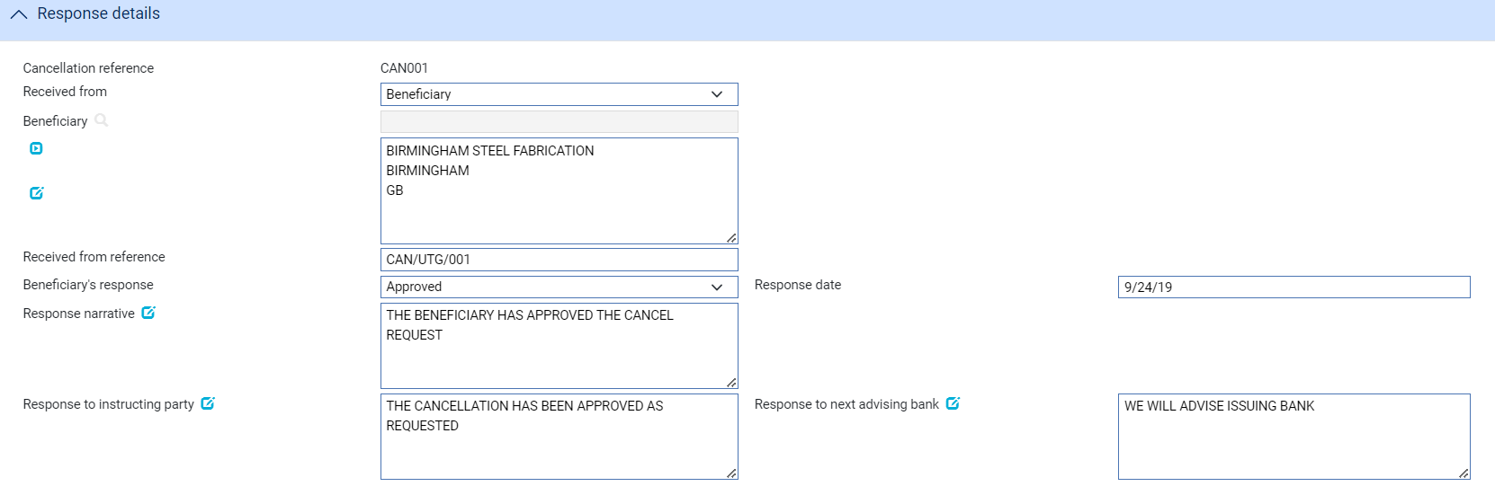

If Rejected, then an additional ‘Reasons for rejection’ fields is shown:

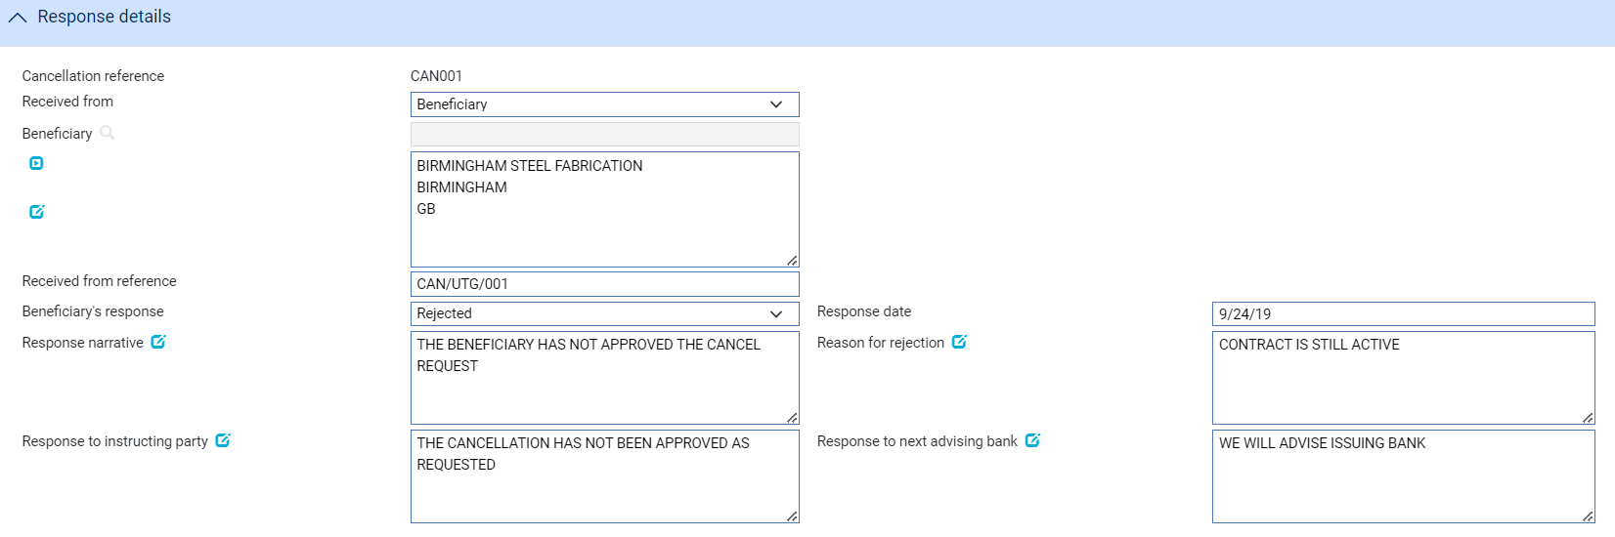

The remaining fields in this window displays cancellation details taken from the original Cancel event.

# Processing Additional Payment Details

This chapter explains how to use the Associated Payment Details pane to apply further processing against the payment or part payments being made.

## Processing Associated Payment Details

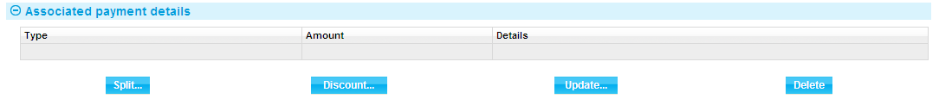

The Associated Items pane allows you to apply further processing against the payment or part payments being made. As payments are defined they are listed in this pane. You can select them individually and enter details of:

* An assignment to a third party
* A discount - click the **Discount** button
* A license - click the **Licenses** button. See the Licenses User Guide – Trade Innovation for further instructions

### Assigning Proceeds to a Third Party

Click the **Split** button that appears in the Associated Payment Details pane.

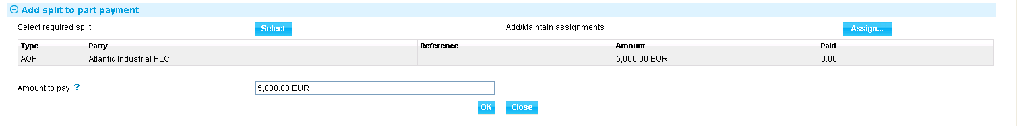

In the window that appears the system lists all assignments of proceeds (AOP), transfer letters of credit (TRF) and back-to-back letters of credit (BTB) created against the parent transaction, showing for each:

* The name of the beneficiary or assignee
* The original amount allocated
* The amount paid to date

Select the third party to whom you wish to assign proceeds and click **Select**.

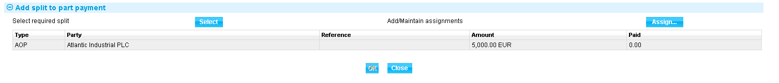

The system displays the amount to be assigned, which you can overtype. Click **Assign** to assign the amount to the selected third party.

### Discounting Payments

1. The functionality described in this section is available only if you do not have the financing module implemented.

For payments where you have checked both the Eligible box and the Hold box, the Discount button in the Associated Payment Details pane is enabled.

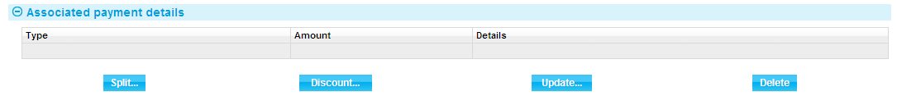

This allows you to record details of a payment to be made to the presenter before the date due under the terms of the master record.

When you click the **Discount** button the system opens a window for you to enter details of the discount.

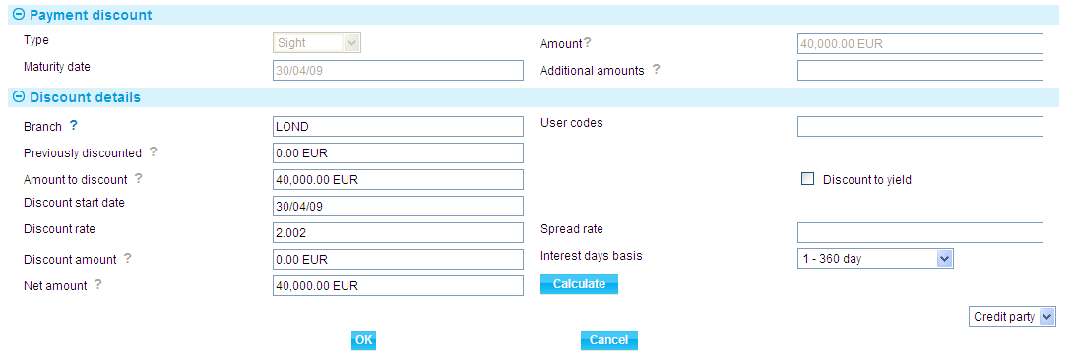

Details of the payment or part payment being discounted are displayed at the top of the window. The table below explains what to enter into the field in this window. Clicking the **Calculate** button updates the fields, using the values you have entered.

|  | Field | What to Enter |
| --- | --- | --- |
|  | Previously Discounted | If a discount has already been given against the transaction, the amount against which the discount was given. |
|  | Amount to Discount | The amount of the discounted payment for which the early payment is to be made. This may be up to the amount due under the part payment, including additional amounts. |
|  | Discount Date | The date the discounted payment is to be made. The system uses today's date as a default. |
|  | Spread Rate | The spread rate that has been added to the interest rate. This is used for reporting purposes only. |
|  | Days Basis | The days basis to be used to calculate the interest. A list of valid values is given in the Common Facilities User Guide – Trade Innovation. |
|  | Discount to Yield | Click once on the Discount to Yield box so that it is checked if the discount to yield formula is to be used to calculate the discount instead of the standard discount formula. |
|  | Discount Amount | The amount of the discount. If you enter the interest rate into the Discount Rate field, the system calculates the discount and displays it in this field, where you can overwrite it. Alternatively, you can enter the discount value directly into this field and the rate will be automatically recalculated. |
|  | Discount Rate | The interest rate to be used to calculate the discount interest amount. Enter the overall rate at which discount is to be calculated (including the spread).  Alternatively, you can enter the discount as an amount in the Discount Amount field. |
|  | Net Amount | The total value of the early payment, taking into account any discount due. |
|  | Discount Paid By | Indicate which party is to pay the discount on the early payment. |
|  | Branch | The branch that owns the discount deal. |

# Appendix Payment Actions and Charges

This appendix explains how the system handles the processing of charges during a payment event for received undertakings.

This appendix covers only the special processing for undertakings. For a full account of how the system handles charges see the Common Facilities User Guide – Trade Innovation.

## Charges

When requesting payment, requesting pay or extend or asking for authorisation to pay, for an undertaking it is sometimes necessary for the bank to advise the issuing bank of charges that will be due from the applicant.

If you select the Release Items|Charges link during a payment event, then when you have For Master selected, the system will display an additional button - the **Claim All** button.

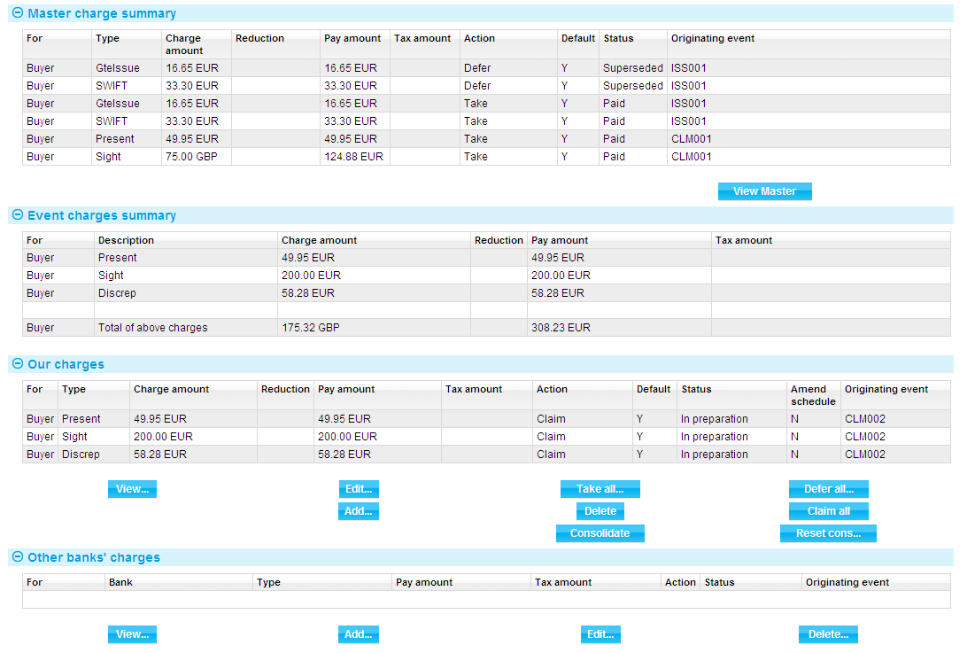

For more on the Charges Summary window see the Common Facilities User Guide – Trade Innovation.

If you click the **Claim All** button, the system changes the value in the Action column to 'Claim' for all charges with a status of 'Outstanding' or 'In Preparation'. When the event is completed, the status of these charges changes to 'Claimed'. This indicates that the charges have been claimed by the bank, but payment has not yet been authorised or paid. No postings are generated by the claim as no payment has yet been made.

If the response does not authorise payment of the claim, you will need to manually take all previously-claimed charges. The system will issue a warning that these charges relate to an outstanding payment event and are being superseded. Once taken, these previously-claimed charges can be waived or edited in the usual way.

## Presenter's Actions

The following table lists all the presenter's actions supported by the system and explains when they might be used:

|  |  |
| --- | --- |
| Presenter's action | What it Signifies |
| Request To Pay or Extend | A request is sent to the applicant to either pay the demand or extend the undertaking expiry date |
| Request Authorisation to Pay | Discrepancies have been advised by the presenter and authorisation to pay is being requested. If this option is selected, an extra field is displayed, allowing you to enter details of discrepancies. |
| Pay and Claim Reimbursement | The sender has paid the beneficiary and has sent a claim to the reimbursing bank. |
| Request Payment | The presenter is requesting payment. |
| Request Acceptance | The presenter is requesting payment and or acceptance of drafts. |
| Sender has Debited our Account | The presenter has paid the beneficiary and has debited the receiver's account. |
| Documents Sent On Approval | Documents with discrepancies have been sent on approval. |
| Other | Used when the payment action involves more complex instructions, for example where discounting of acceptances is being requested. The Notes fields should be used to provide details. |

## Payment Actions

The Payment Action field allows you to select the appropriate action for the claim. Actions are of the following types:

Payment actions that indicate that the bank is paying or will pay the claim in the future and so complete the claim. These include:

* Approve Authorisation Request
* Pay
* Pay with Financing
* Pay at Maturity
* Issue Trust Receipt Loan
* Accept
* Forward Documents

Payment actions that reject or refuse and so complete the claim. These include:

* Refuse Documents
* Reject
* Reject and Claim Refund
* Reject Authorisation Request

Payment actions that leave the claim outstanding. These include:

* Request To Pay Extend
* Await Documents
* Request Approval from Applicant
* Issue Trust Receipt
* Issue a General Request to Applicant or Presenter

Payment actions that complete the claim without paying/rejecting

* Extend – an amend event is automatically created

1. In addition to the standard actions mentioned above, your bank may define other actions (which are based upon the standard actions) in order to satisfy your internal processes. These additional actions will also be available in the drop-down list.

See the *System Tailoring Guide* – Trade Innovationfor instructions on defining additional payment actions.

### The Effect of Different Payment Actions on Charges

The following table indicates the effect of different payment action behaviours on charges for received undertakings:

| Payment Action Behaviour | What it Does | Our Charges for Buyer | Our Charges for Seller | Other Party Charges | Other Bank's Charges for Buyer | Other Bank's Charges for Seller |
| --- | --- | --- | --- | --- | --- | --- |
| Request to Pay or Extend | Used where the Beneficiary request the Applicant either pays the Demand or alternatively extends the term of the undertaking | Take | Take | Take | Take | Take |
| Extend | Used where the Applicant agrees to extend the term of the undertaking | Take | Take | Take | Take | Take |
| Accept | The main purpose of acceptance is to confirm the maturity date of an acceptance payment and to allow the drafts to be returned or discounted. The payment is then treated as a pay at maturity, allowing the payment to be paid as the due date is reached.  This is available for acceptance payments only. | Claim | Defer | Claim | Claim | Claim |
| Approve Authorisation Request | Only available if discrepancies advised by another bank. In this case a further drop down list appears allowing the user to enter the appropriate additional authorisation details:   * See details * Accept * Remitted - note value date field is then shown * Debit sender's account * Negotiate * Claim reimbursement   This is available only if the presenter's action is 'Request Authorisation to Pay'. | Take | Take | Take | Take | Take |
| Await Documents | Used where the presentation was made in advance of the documents being received.  This is available only where presentation is by a bank. | Defer | Defer | Defer | Defer | Defer |
| Issue a General Request to Issuing Bank, Presenter or Transferee | This can be used to send correspondence about the claim to the issuing bank or presenter by entering details into the Notes for Presenter or Notes for Issuing Bank field, as appropriate. | Take | Take | Take | Take | Take |
| Pay | The presentation is being paid. If a single payment is being entered, then the payment will be made and an MT754, MT765 or equivalent will be sent to the principal party (issuing bank)  If the payment is mixed then this indicates the documents are payment is to be made. Each part payment is initially set to have a status of 'pay' which can be overridden as required to one of the following pay statuses:   * Pay * Pay at maturity * Accept (if acceptance part payment only) | Take | Take | Take | Take | Take |
| Pay and Claim Reimbursement | The presentation is being paid and a reimbursement claim is to be sent to the reimbursing bank. The payment is left outstanding until funds are received from the reimbursing/issuing bank. | Take | Take | Take | Take | Take |
| Pay at Maturity | The payment will be made at maturity. The payment advices such as MT754, MT765 can be produced immediately and the payment will be automatically picked up as the maturity falls due so that it can be continued and paid. | Claim | Defer | Claim | Claim | Claim |
| Pay from Suspense | As for Await Replacement Invoices, but additionally would be used to pay the second beneficiary from suspense. | Defer | Defer | Defer | Defer | Defer |
| Pay with Discrepancies | As for Pay, but discrepancy details can be entered. | Take | Take | Take | Take | Take |
| Refuse Documents | Documents are refused. What happens to the documents depends on what is selected in the Document Disposal field. If 'Return' is selected, payment status is set to 'Reject', otherwise it is set to 'In Progress'. If a mixed payment this applies to all part payments. If a payment if refused but documents are held this allows the claim to be continued when the presenter re-presents the required documents. That is, the item will be available for further action in the process outstanding claim. | Take | Take | Take | Take | Take |
| Reject | Used where presentation is not in order.  This is available only where presentation is by a bank. | Take | Take | Take | Take | Take |
| Reject and Claim Refund | Used where the presenting bank has debited the receiver's account. In this case details of the refund value date are included.  This is available only where presentation is by a bank. | Take | Take | Take | Take | Take |
| Reject Authorisation Request | Used to refuse a request for payment where discrepancies have been advised.  This is available only if the presenter's action is 'Request Authorisation to Pay'. | Take | Take | Take | Take | Take |
| Request Acceptance | The bank will not pay the beneficiary until funds have been received from the issuing bank. This covers both the request for payment and request for drafts to be accepted.  This is available for acceptance payments only. | Claim | Defer | Defer | Claim | Claim |
| Repay Finance | Allows the user to create a Repay Finance event. | Take | Take | Take | Take | Take |
| Request Authorisation to Pay | Used when documents have discrepancies. The bank does not pay but seeks authorisation to pay from the issuing bank. | Claim | Defer | Defer | Claim | Claim |
| Request Payment | The bank will not pay the beneficiary until funds have been received from the issuing bank. | Claim | Defer | Defer | Claim | Claim |
| Send Documents On Approval | This is essentially the same as request authorisation to pay. The documents are essentially being handled as a collection. | Claim | Defer | Defer | Claim | Claim |
| Reverse Payment | The bank reverses a part payment that has already been paid. | Take | Take | Take | Take | Take |